****

**FACILITATING AND LEARNING MATERIAL FOR**

**INTRODUCTION TO TECHNICAL DRAWING**

**National Certificate I**

**GENERIC AREA: TECHNICAL DRAWING**

UNIT 1 – Introduction to Technical Drawing

**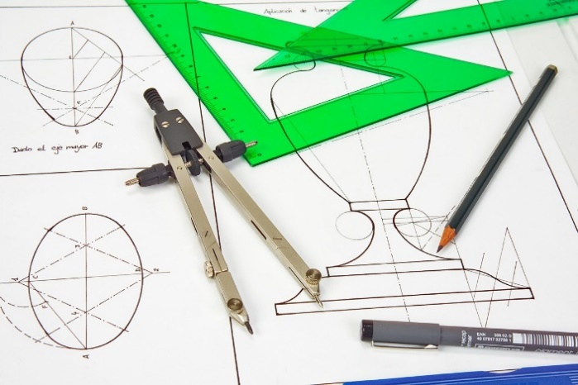**

**LEARNING OUTCOMES**

| **1** | Demonstrate knowledge of technical drawing |
| --- | --- |
| **2** | Demonstrate skills in basic technical drawing equipment, materials and their maintenance |
| **3** | Demonstrate skills in symbols, numbers, letters, and abbreviations |
| **4** | Demonstrate skills in lines, linear measurements, dimensioning and freehand sketching |
| **5** | Demonstrate skills in plain and diagonal scales |

Table of Contents

[HOW TO USE THIS DOCUMENT. 4](#_Toc147910912)

[UNIT INTRODUCTION 5](#_Toc147910913)

[ICONS AND THEIR MEANINGS 6](#_Toc147910914)

[LO 1. Demonstrate knowledge of Technical Drawing 7](#_Toc147910915)

[PC (a) Explain Technical Drawing 7](#_Toc147910916)

[PC (b) Explain importance of technical drawing at the work environment 7](#_Toc147910917)

[PC (c) State skills acquired in technical drawing 9](#_Toc147910918)

[PC (d) Explain Usage of Basic Equipment in Technical Drawing. 9](#_Toc147910919)

[Self-Assessment 1 13](#_Toc147910920)

[LO 2. Demonstrate skills in basic technical drawing equipment, materials and their maintenance 15](#_Toc147910921)

[PC (a) Prepare technical drawing equipment and materials for drawing. 15](#_Toc147910922)

[Prepare to draw 15](#_Toc147910923)

[PC (b) Select appropriate sizes of technical drawing sheet for a given work 17](#_Toc147910924)

[PC (c) Draw a plane figure using technical drawing equipment. 19](#_Toc147910925)

[PC (d) Care and maintain technical drawing equipment 21](#_Toc147910926)

[Self-Assessment 2 23](#_Toc147910927)

[LO 3. Demonstrate skills in usage of symbols numbers, letters, and abbreviations. 25](#_Toc147910928)

[PC (a) Explain symbols, numbers, letters and abbreviations in technical drawing 25](#_Toc147910929)

[PC (b) Explain importance of symbols, numbers, letters and abbreviations in technical drawing. 27](#_Toc147910930)

[PC (c) Use Basic Abbreviations and Symbols in Technical Drawing 28](#_Toc147910931)

[PC (d). Practice writing of numbers and letters in Technical Drawing 31](#_Toc147910932)

[PC (e) Use numbering and lettering skills in technical drawing. 34](#_Toc147910933)

[Self-Assessment 3 37](#_Toc147910934)

[LO 4. Demonstrate skills in lines, linear measurements, dimensioning and freehand sketching in technical drawing 40](#_Toc147910935)

[PC (a). Explain lines used in technical drawing. 40](#_Toc147910936)

[PC (b) Explain linear measurement and dimensioning. 42](#_Toc147910937)

[PC (c) Apply types of lines used in technical drawing to draw geometrical objects. 43](#_Toc147910938)

[PC (d) Convert linear measurements. 49](#_Toc147910939)

[PC (e). Apply principles of dimensioning in geometrical shapes. 56](#_Toc147910940)

[PC (f). Use freehand techniques to draw basic geometrical figures with dimensions. 61](#_Toc147910941)

[Self-Assessment 4 69](#_Toc147910942)

[LO 5 Demonstrate skills in plain and diagonal scales 72](#_Toc147910943)

[PC (a) Explain Scales 72](#_Toc147910944)

[PC (b) State reasons for scaling 74](#_Toc147910945)

[PC (C) Differentiate between plain and diagonal scales, 74](#_Toc147910946)

[PC (e) Draw Basic Geometrical Figures Using Diagonal and Plain Scales 77](#_Toc147910947)

[References 83](#_Toc147910948)

# HOW TO USE THIS DOCUMENT.

The unit is structured into three or more learning outcomes. A learning outcome (LOs) is a statement that specifies what learners will know or be able to do as a result of a learning activity. LOs are usually expressed as knowledge, skills or attitudes. Each learning has a minimum of four Performance Criteria (PC). A Performance criterion is the sub-activities of an LO.

You are required to read and practice activities to gain the relevant knowledge and skills associated with each LO. Some of the LOs will require you to access extra readings and videos to assist in your learning. This material is prepared to encourage you to work independently and to make decisions concerning how you might approach a task. Some of the LOs have key concepts which will briefly explain relevant terminologies and concepts within their respective PCs.

You will be assessed through formative (assignment and class exercise) and summative (end of unit project work and portfolio) approaches. The assessment will take the form of writing, oral and practical demonstration.

# UNIT INTRODUCTION

You are welcome once again to this learning material. This material introduces learners to Technical Drawing. This unit draws your attention to the knowledge of technical drawing, skills in basic technical drawing equipment, materials and their maintenance, skills in symbols, numbers, letters, and abbreviations, skills in lines, linear measurements, dimensioning and freehand sketching and skills in plain and diagonal scales.

This learning material has been written to encourage you to work on your own. It is full of activities that will help you to work independently and to make decisions concerning how you will approach a task in this unit. Follow the instructions and the steps indicated in this learning material and work independently as possible.

The next page shows the symbols (icons) that will be used frequently in this material. It also gives the meaning of the icons, so that any time you see the icon, you will understand what it means. Please feel free to ask your facilitator any questions you have as you read the material.

Have fun and enjoy reading the material!

# ICONS AND THEIR MEANINGS

The meaning of each icon is provided in Table 1. You will come across these icons in the material, and you should know what each of them represents. Carefully observe the icons and their meanings.

| # | Icons | Meaning |
| --- | --- | --- |
| 1 |  | Learning Outcome |
| 2 |  | Self- Assessment |

**Table 1: Icons and their meanings**

Congratulations for going through the icons and their meanings! We will next look at the activities under LO 1. 

# LO 1. Demonstrate knowledge of Technical Drawing

This LO is developed to help you acquire knowledge of technical drawing, explain the importance of technical drawing, state skills acquired in technical drawing and explain usage of basic equipment in technical drawing, as per PC’s (a) – (d).

## PC (a) Explain Technical Drawing

Technical drawing is a universal technical language for effective communication among professionals in the manufacturing sector and it is therefore an important subject in technical, vocational education and training (TVET). It offers prerequisite knowledge and skills for a number of technical and vocational areas of work. The subject helps the leaner to develop three-dimensional intelligence, imaginative and drawing skills so that the learner becomes creative in solving many of the social, economic and professional problems that need designing before production. Finally technical drawing is an international language in which a combination of different types of lines are used to express specific ideas. It covers the following areas: plane geometry, solid geometry, graphical resolution of forces, building and engineering drawing. For example, engineers, architects, designers, and other professionals may be using drawing done by someone but must understand it and use it correctly.

## PC (b) Explain importance of technical drawing at the work environment

Technical drawing plays a crucial role in various work environments, including engineering, architecture, manufacturing, and many other fields.

Its importance lies in the following key aspects:

1. **Graphical Communication**

Technical drawing serves as a universal language that enables effective communication among professionals, teams, and stakeholders. They convey complex ideas, designs, and specifications in a clear and standardized format, reducing the chances of misinterpretation or miscommunication.

1. **Design and Planning**

Technical drawings are essential during the initial design and planning stages of projects. Engineers, architects, and designers use drawings to visualize concepts, refine ideas, and make critical decisions about dimensions, materials, and layout. This helps to ensure that the final product meets the desired standards and requirements.

1. **Precision and Accuracy**

Technical drawings provide precise measurements and specifications, which are crucial in industries where even small errors can have significant consequences. These drawings ensure that components fit together correctly, machinery operates smoothly, and structures are safe and stable.

1. **Problem Solving**

When issues or challenges arise during a project, technical drawings are valuable tools for identifying and resolving problems. They enable professionals to find out mistakes, analyse potential solutions, and make correct decisions.

1. **Reduce wastage of material (Cost Control)**

Technical drawings play a role in cost estimation and control. By providing detailed information about materials, dimensions, and processes, they help in accurate budgeting and resource allocation.

1. **Compliance and Regulation**

Industries are subject to strict regulations and standards. Technical drawing helps ensure that designs and products meet these requirements, reducing legal and liability risks.

1. **Training and Education**

Technical drawings are used in educational settings to teach students about design principles, engineering concepts, and manufacturing processes. They are essential for training future professionals in various fields.

1. **Innovation**

Technical drawing allows for innovation. Engineers and designers can experiment with different concepts and quickly assess their feasibility through drawings before committing to physical prototypes for production.

## PC (c) State skills acquired in technical drawing

**Skills to be acquired in technical drawing**

a. Freehand sketching

b. Interpretation of symbols and abbreviation

c. Appropriate usage of equipment

## PC (d) Explain Usage of Basic Equipment in Technical Drawing.

Equipment are crucial for engineers, architects and designers to create precise drawings of mechanical, architectural, or engineering designs, allowing them to convey complex ideas accurately and clearly.

Below are technical drawing equipment and their uses;

Table 1.1: Usage of basic equipment

|  |  |  |
| --- | --- | --- |
| EQUIPMENT | PICTURE | USAGE |
| T-square | engineering drawing t square Cheap Sell - OFF 66% | For drawing horizontal lines |
| Pair of compass | Pair of compasses hi-res stock photography and images - Alamy | For drawing arcs, circles and also to mark off distances. |
| Set square(45°) | What Is a Set Square? (with pictures) | In conjunction with T- square to draw vertical lines and lines inclined at 45° and 90° |
| Set square (30°/60°) | What is a set square? - Quora | In conjunction with T- square to draw vertical line, and lines inclined at 30°/60° and 90° |
| French curve |  | For drawing smooth curves and shapes |
| Eraser | Eraser Vector Art, Icons, and Graphics for Free Download | For correcting mistakes |
| Protractor | Office Depot Brand Semicircular 6 Protractor Clear - Office Depot | For measuring angles |
| Scale rule | 15cm Jumbo Ruler - The Promo Group | #1 in Corporate Gifting | For measuring and cheeking measurement |
| Pair of divider |  | For measuring and transferring measurements |
| Pencils | C:\Users\User\AppData\Local\Packages\5319275A.WhatsAppDesktop_cv1g1gvanyjgm\TempState\DB8E1AF0CB3ACA1AE2D0018624204529\WhatsApp Image 2023-09-19 at 12.44.55.jpg | H-Pencil is use for drawing continuous thick lines (outlines)  2H- use for drawing continuous thin lines (constructional lines)  HB- Pencil is use for freehand sketching, lettering, numbering and hatching.  B- Pencil is use for shading |
| Drawing board | White Pine Wood Drawing Board, Size: 23 X 32 Inch | It provides stable and flat surface for drawing |
| Clips | Drawing Board Clip M/S – Continental Books and Stationery Services | It is used to hold drawing sheet on the drawing board |
| Sharpener |  | It is used to sharpen pencil to form a conical shape. |

## 

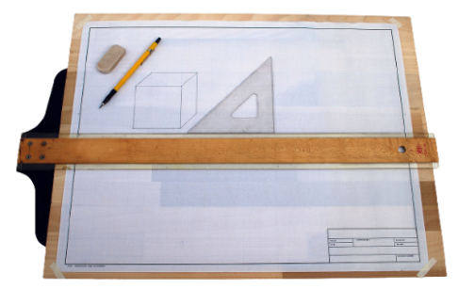

Figure 1.1: Usage of Drawing board, Tee-Square and Set-Squares

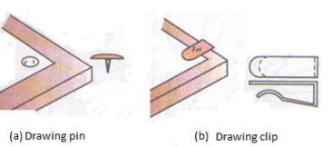

Fig**ure 1.2: Usage of drawing clip**

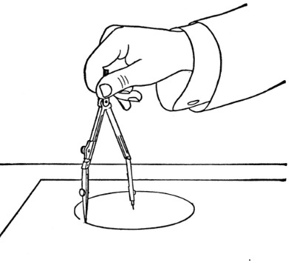

**1Figure 1.3: Usage of a Pair of compasses**

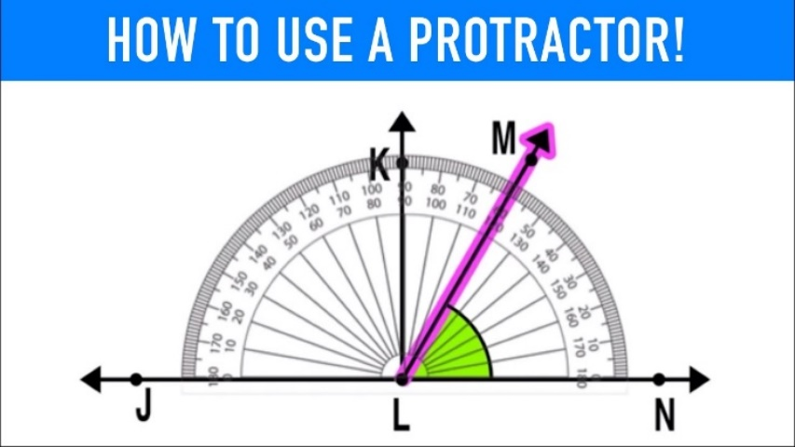

**Figure 1.4 Usage of a Protractor**

# Self-Assessment 1

This learning outcome (LO) has a little quiz at the end. I recommend you to take this whole quiz without looking back for any of the answers. This meant to help you determine how well you have understood this learning outcome. Now assess yourself with the questions below.

1. What is a technical drawing?

……………………………………………………………………………………………………………………………………………………………………………………………………………….

………………………………………………………………………………………………………..

2. Explain **Two (2)** importance of technical drawing at the work environment

………………………………………………………………………………………………………………………………………………………………………………………………………………………………………………………………………………………………………………………………………………………………………………………………………………………………

1. List **Two (2**) skills to be acquired in technical drawing.

……………………………………………………………………………………………………………………………………………………………………………………………………………………………………………………………………............................................................................

1. State the use of the following technical drawing equipment
2. Pair of compasses……………………………………………………………………………………...

…………………………………………………………………………………………………………

1. 2H Pencil……………………………………………………………………………………………….

…………………………………………………………………………………………………………

………………………………………………………………………………………………………....



We believe that you can now explain technical drawing, explain the importance of technical drawing, state skills acquired in technical drawing and explain usage of basic equipment in technical drawing. Well done!

# LO 2. Demonstrate skills in basic technical drawing equipment, materials and their maintenance

This LO is developed to help you acquire skills in preparing technical drawing equipment and materials for drawing, select appropriate sizes of technical drawing sheet for given work, draw a plane figure using technical drawing equipment and maintain technical drawing equipment as per PC’s (a)-(d).

## PC (a) Prepare technical drawing equipment and materials for drawing.

Before you start to draw, you need to prepare your drawing equipment and materials for drawing. To achieve this, follow the steps below:

## Prepare to draw

**Steps:**

1. **Set and Fasten your paper on drawing board with clips**
2. T- Square must be placed against the edge of the drawing board (No gab to be left around)

**Figure 2.1: Setting of T-square and drawing board**

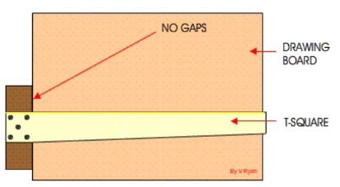

1. The paper should rest on the T- square (No gaps) and firmly held with clips or paper tape.

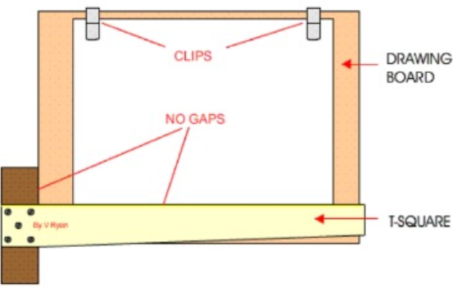

**Figure 2.2. setting the Drawing Sheet**

1. Draw boarder lines and title block

Steps:

1. Boarder line and title block are then drawn as shown.

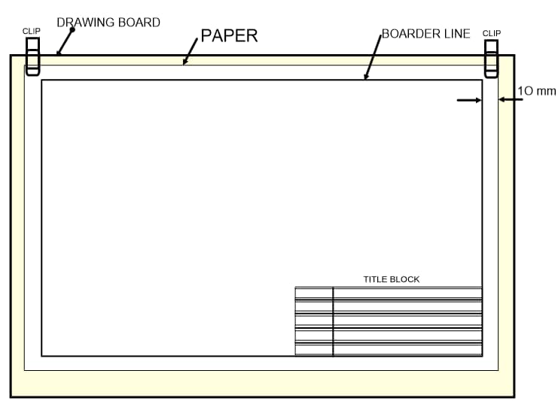

**Figure 2.3: Drawing Boarder lines and Title Blocks**

1. Insert the relevant information in the title block.

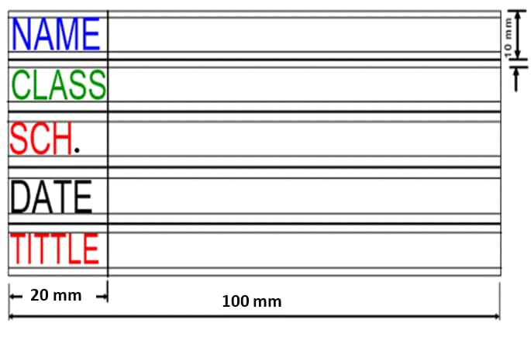

**Figure 2.4: Title Block**

## PC (b) Select appropriate sizes of technical drawing sheet for a given work

Technical drawing sheets are in different ranges and are selected based on dimensions of a given drawing. The most commonly used sheet is from A4 to A0. The range of sizes of drawing paper with A0 being the largest and A4 being the smallest. The figure below shows the range of papers used in technical drawing. The A3 is twice the size of A4, A2 is also twice the size of A3 and A1 is also twice the size of A2.and A0 is twice the size of A1 depicted the diagram below.

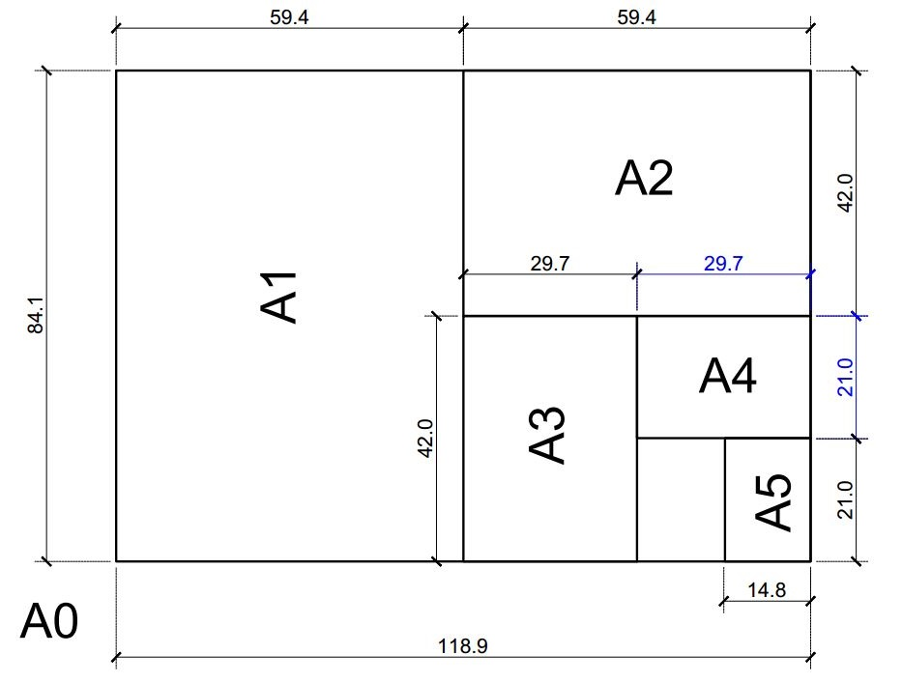

Figure 2.5: Sizes of Drawing Papers



The Table below shows the sizes of drawing sheets used in technical drawing

Table 2.1: Standard Sizes of Drawing Sheets as per BIS

|  |  |  |
| --- | --- | --- |
| **Designation** | **Size (mm)** | **Proper selection of Sheets for usage** |
| A0 | 841× 1189 | Large format printing and drawing. Example; Architectural and Engineering drawing, posters and banners. |
| A1 | 594× 841 | Architectural and Engineering drawing and posters |
| A2 | 420× 594 | Posters, architectural drawing and design sketches |
| A3 | 297× 420 | Architectural Drafting. |
| A4 | 210 ×297 | Freehand sketches and printing documents |

## PC (c) Draw a plane figure using technical drawing equipment.

There are several plane figures, however we shall limit ourselves to the drawing of plane figures like: triangles, square and circle using only one method each in this performance criterion.

**Draw a triangle**

**To draw a triangle, given one of the sides.**

**Steps:**

1. Draw a line AB, equal to the given length of side (30mm).
2. With compass point on A and radius AB, draw an arc as shown.
3. With compass point on B, and with the same radius, draw another arc to cut the first arc at C.
4. Join the points to form the triangle ABC.

A

B

C

**Figure 2.6: Construction of Triangle**

**Draw a square**

To draw a square given the length of the side

1. Draw a line AB to the required length
2. Using ‘A’ as the centre and convenient radius draw an arc EF
3. with centre at E and the same radius step off along the arc twice to

D

C

A

B

E

F

G

H

give points G and H.

1. With centres G and H draw arcs of the same radius to cross at P.
2. Join AP to form a perpendicular line.

**Figure 2.7: Construction of a Square**

1. With centre at A draw an arc from B to cut the perpendicular at C.
2. With radius equal to the length of side and centres at B and C draw

arcs to intersect at D.

1. Join BCD to form the required square as shown above.

**Draw a circle**

**To draw a circle having a radius of 20mm**

A

B

C

R 20mm

D

Steps:

1. Draw a line AB and CD and label the intersection as ‘O’

O

1. With ‘O’ as centre and radius of 20mm, draw the circle.

**Figure 2.8: Construction of a Circle**

## PC (d) Care and maintain technical drawing equipment

Taking care and maintaining your drawing equipment is essential as this not only prolong their life span but also ensure neatness and good work.

Below are some ways of taking care and maintaining drawing equipment:

**The Drawing Board:**

i). Never leave drawing clips on drawing board

ii). The drawing board should be kept clean always.

iii). Ensure the surface and edges are never damage.

**The set squares**

i). Clean set squares before and immediately after use.

ii). Always keep set square in their plastic covers after use.

iii). they must be kept flat and away from heat.

iv). Ensure the edges are not damaged.

**A Pair of compasses and dividers**

i). Clean and keep them in their containers immediately after use.

ii). Ensure their points are sharp always

iii). Ensure pair of compasses and dividers are well tightened

iv). Avoid dropping the instrument.

**The Tee -Square**

i). The stock and blade should be maintained at right angle always.

ii). The Tee-square must always be cleaned before use and immediately after use

iii). The beveled edge of the Tee- square must be kept from damage.

**Pencils**

i). Pencils must be sharpened to their individual shapes (conical and chisel-edge) and kept in the pencil boxes

ii). Avoid accidental dropping of Pencil as the may break.

**The drawing sheets**

Keep drawing sheet clean always and if possible, keep them in folders.

**Observation Checklist**

|  |  |  |  |  |  |  |  |
| --- | --- | --- | --- | --- | --- | --- | --- |
| **Learning Outcome 2** | | | **PC (a) – (d)** | | | |  |
| **No** | | **Criteria**  **Based on the specifications given to the Learner by the Assessor** | | **Competence**  **Achieved (A) or**  **Not Achieved (N)** | | |  |
| **A** | **NA** | **Remarks** |  |
| 1 | Ability to select appropriate drawing sheet sizes for a specific work. | | |  |  |  |  |
| 2 | Correct setting and fastening of drawing sheet. | | |  |  |  |  |
| 3 | Ability to draw boarder lines and Title block | | |  |  |  |  |
| 4 | Precision measurement of distances | | |  |  |  |  |
| 6 | Proper application of bisection of lines | | |  |  |  |  |
| 7 | Ability to construct intersecting arcs | | |  |  |  |  |
| 8 | Ability to construct a square | | |  |  |  |  |
| 9 | Observance of Neatness of work, care and maintain ace of drawing equipment | | |  |  |  |  |
| 10 | Correct care and maintenance of equipment | | |  |  |  |  |



# Self-Assessment 2

This learning outcome (LO) has a practical assignment to help you master the skill in basic technical drawing equipment, materials and their maintenance. I recommend you to spend some time and do the practical assignment to determine how well you have understood this learning outcome. Now assess your learning skills by undergoing the practical activities below.

You will be provided with equipment and materials to:

1. Select appropriate size of drawing sheets for the following drawing activities.
2. Posters
3. Architectural drafting
4. Banners

Sizes of Drawing Sheets

AO, A1, A3, A2 and A4

………………………………………………………………………………………………………………………………………………………………………………………………………………………………………………………………………………………………………………………………………………………………………………………………

1. Draw boarder line and title block

………………………………………………………………………………………………………………………………………………………………………………………………………………………………………………………………………………..

1. Construct a square with side 50mm

We believe you can now Prepare technical drawing equipment and materials for drawing, Select appropriate sizes of technical drawing sheet for given work, Construct a plane figure using technical drawing equipment, Care and maintain technical drawing equipment as per PC’s (a)- (d)

# LO 3. Demonstrate skills in usage of symbols numbers, letters, and abbreviations.

This LO is developed to help you acquire skills in explanation of symbols, numbers, letters and abbreviations in technical drawing, explain importance of symbols, numbers, letters and abbreviations. You will be able to communicate in Technical Drawing through the usage of basic abbreviations and symbols, practice writing of numbers and letters, use numbering and lettering skills as per PC’S (a) – (e).

## PC (a) Explain symbols, numbers, letters and abbreviations in technical drawing

Symbol intechnical drawing are used to convey specific geometrical details to others through lines. Symbols in technical drawing serve as standardized graphical representations, conveying precise information and aiding in clear communication of design elements and specifications.

There are many symbols in technical drawing however we shall limit ourselves to the ones listed below.

**Table 3.1: Symbols and their meanings**

|  |  |
| --- | --- |
| **BASIC SYMBOLS** | **MEANING** |
| Ø | Diameter  (comes before a dimension) |
| ° | Degree ° |
|  | First angle |
|  | Third angle |
|  | Centre line |
| ̸ | Per |
|  | Square  (comes before a dimension) |

**Abbreviation**

Abbreviations in technical drawing are concise symbols or shorthand notations used to represent common geometric shapes, features, materials, or instructions, streamlining communication and enhancing clarity within engineering and design documentation.

**Note**: full stops are not used except when the abbreviation makes a word which may be confusing, example NO. for number.

Table 3.2: Abbreviation and their meanings

|  |  |
| --- | --- |
| **ABBREVIATION** | **MEANING** |
| mm | Millimeter |
| Cm | Centimeter |
| Dm | Decimeter |
| M | Meter |
| Dm | Decameter |
| Hm | Hectometer |
| Km | Kilometer |
| A/F | Across flat |
| A/C | Across corners |
| Dia | Diameter  (preceding a note) |
| Rad | Radian |
| DRG | Drawing |
| R | Radius  (comes before a dimension, capital only) |
| ISO | International standard organization |
| SI | System international |
| Sq | Square  (in a note) |

**Lettering**

Lettering is the process of putting information on drawings. It deals with sizes of the parts drawn, specification of materials and other pieces of information which makes the drawing complete.

There are two types of letters popularly termed as cases: lower case (small letters) and upper case (capital letters)

**Numbering**

Numbering is the correct use of numbers in technical drawing. They provide essential measurements and dimensions, ensuring accuracy, consistency, and effective communication of a drawing.

## PC (b) Explain importance of symbols, numbers, letters and abbreviations in technical drawing.

**Importance of Symbols and abbreviations**

1**. Save time and cost**. They provide a quick way of communicating information without having to write out lengthy descriptions.

2. **Make annotations simpler**. They are used to simplify complex Information, making it easier for engineers and other professionals to understand what is being conveyed in the drawing.

3**. Makes work clearer**. (They improve accuracy and clarity).

It makes reading of drawing easier and simpler.

4. **Maintain standard**. To increase standardization: Abbreviations and symbols are standardized in drawing, which allows for more efficient communication between designers and other professionals.

**Importance of lettering and numbering.**

Lettering and numbering forms an important part of drawing and is used to write letters, dimensions, notes and such other necessary information as may be required for complete execution of the drawing of an object**.**

**Accurate lettering and numbering ensure;**

1. **Clear communication of design intent**. They provide precise identification and labeling, facilitating easy understanding and reference of design elements and measurements.
2. **Preventing errors.** They provide clear labels and references to specific components or dimensions, reducing the likelihood of misinterpretation or errors in technical drawing.
3. **Makes drawing looks real.** Ithelps to dimension, label and identify parts, improving the accuracy of the drawing and making it easier to understand.

## PC (c) Use Basic Abbreviations and Symbols in Technical Drawing

**Table 3.1:**

|  |  |
| --- | --- |
| **PLANE FIGURES WITH ABBREVIATION**  **AND SYMBOLS** | **MEANING** |
| C:\Users\User\AppData\Local\Packages\5319275A.WhatsAppDesktop_cv1g1gvanyjgm\TempState\88EF51F0BF911E452E8DBB1D807A81AB\WhatsApp Image 2023-09-25 at 13.15.17.jpg | **Note.** ‘R’ represents radius ,  The radius is 60mm  This means, the circle is drawn using a radius of 60mm |
| C:\Users\User\AppData\Local\Packages\5319275A.WhatsAppDesktop_cv1g1gvanyjgm\TempState\5352696A9CA3397BEB79F116F3A33991\WhatsApp Image 2023-09-25 at 13.15.18.jpg | **Note;**  **A/C** represent across corners,  The distance between opposite corners is 80 mm. represents millimetre  Across corners means the distance is taken between two opposite corners through the centre.  This means, the hexagon is drawn with distance of 80mm from one corner to the opposite corner. |
| C:\Users\User\AppData\Local\Packages\5319275A.WhatsAppDesktop_cv1g1gvanyjgm\TempState\A5A61717DDDC3501CFDF7A4E22D7DBAA\WhatsApp Image 2023-09-25 at 13.15.17.jpg | **Note:** A/F represents across flat.  The distance between two opposite flat sides is 70mm. represent millimetre.  Across flat means the distance is taken between two opposite sides through the centre.  This means the hexagon is drawn with distance of 70 millimetres from one flat side to the opposite side. |
| C:\Users\User\AppData\Local\Packages\5319275A.WhatsAppDesktop_cv1g1gvanyjgm\TempState\D198BD736A97E7CECFDF8F4F2027EF80\WhatsApp Image 2023-09-25 at 13.15.17.jpg | **Note:** Dia represents diameter,  The diameter is 50 and  mm represents millimetre.  This means the circle is drawn using a diameter of 50 millimetres |
| C:\Users\User\AppData\Local\Packages\5319275A.WhatsAppDesktop_cv1g1gvanyjgm\TempState\2B0F658CBFFD284984FB11D90254081F\WhatsApp Image 2023-09-25 at 13.15.18.jpg | **Note:** Ø represents diameter,  The diameter is 50 and  mm represents millimetre.  This means the circle is drawn using a diameter of 50 millimetres |
| C:\Users\User\AppData\Local\Packages\5319275A.WhatsAppDesktop_cv1g1gvanyjgm\TempState\F48C04FFAB49FF0E5D1176244FDFB65C\WhatsApp Image 2023-09-25 at 13.15.19.jpg | **Note**: Sq represents square,  The side is 60 and  mm represents millimetre.  This means, the square is drawn to a distance of 60 millimetres. |
| C:\Users\User\AppData\Local\Packages\5319275A.WhatsAppDesktop_cv1g1gvanyjgm\TempState\2557911C1BF75C2B643AFB4ECBFC8EC2\WhatsApp Image 2023-09-25 at 13.15.19.jpg | **Note**: represents square,  The side is 30 and  mm represents millimetre.  This means, the square is drawn to a distance of 30 millimetres. |
| C:\Users\User\AppData\Local\Packages\5319275A.WhatsAppDesktop_cv1g1gvanyjgm\TempState\A48564053B3C7B54800246348C7FA4A0\WhatsApp Image 2023-09-25 at 13.15.20.jpg | **Note.** ‘R’ represents radius,  The radius is 40 and  mm represent millimetre,  This means, the circle is drawn using a radius of 40mm |

PC (d). Practice writing of numbers and letters in Technical Drawing

Do you believe practise makes perfect? If yes, then you must make a conscientious effort to practise with all seriousness and you can become perfect at writing numbers and letters. However, the following recommendations must be noted when lettering and numbering;

1. **Consistency**. Letters should be uniform in size, style and spacing to enhance readability.

2. **Legibility**: choose a legible font or lettering style. Overly decorative fonts that can be difficult to read, especially in small text must be avoided.

3. **Alignment**: align your text horizontally and vertically. Use guidelines to keep your letters straight and evenly spaced.

4. **Size variation**: use upper case (capital letters) to show titles and lower case to

footnotes and annotations.

5. **Consistent angle**: maintain a consistent slant or angle for your letters, especially when using italic style.

**Writing of lower- and upper-case letters**

Letters and numbers can be written using single stroke or the gothic letters methods.

**Single stroke letters** meanthickness of the line of the letter should be obtained in one stroke of the pencil. The horizontal lines of letters should be drawn from left to right. Vertical or inclined lines from top to bottom.

Single-stroke letters are of two types: 1. Vertical and 2. Inclined

Inclined letters lean to the right, the slope being 75˚ with the horizontal. The size of a letter is described by its height.

**Gothic letters**: Gothic letters are formed by thickening the stems of single-stroke letters. These are mostly used for main titles of ink-drawings. The outlines of the letters are first drawn with the aid of instruments and then filled-in with ink. The thickness of the stem may vary from 1/5th to 1/10th of the height of the letters.

Practice your lettering skills regularly to improve your technique and confidence. Consider copying existing drawings or creating dedicated lettering practice sheets. It must be kept in mind that use of drawing instrument takes considerable amount of useful time and hence must be avoided as far as possible.

Practice the letters and numbers below using single stroke letter method.

**Upper Case letters (Capital letters)**

A B C D E F G H I J K L M N O P Q R S T U V W X Y Z

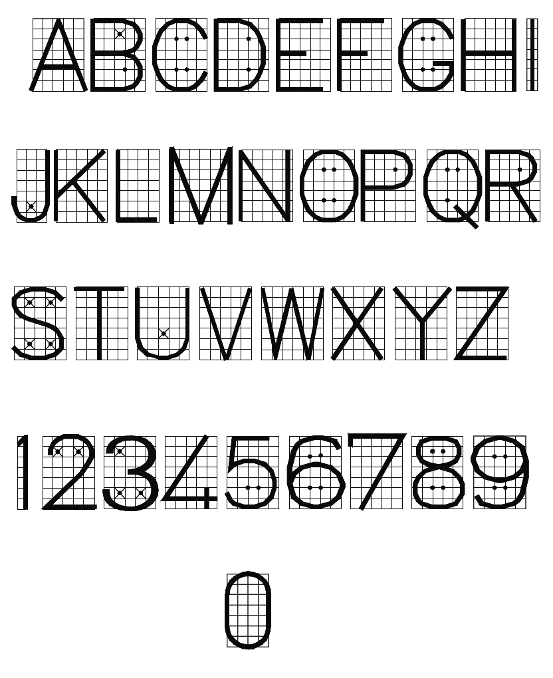

**Figure 3.1: Upper case single stroke vertical method**

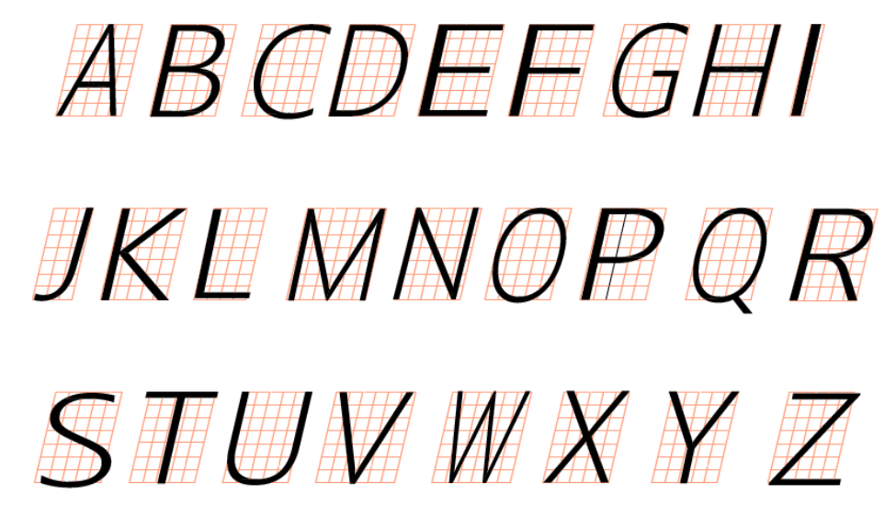

**Figure 4.2: Upper case single stroke inclined**

a b c d e f g h i j k l m n o p q r s t u v w x y z

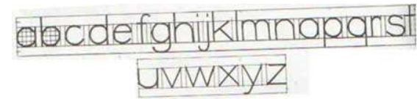

**Figure 3.3: Lower case single stroke vertical method**

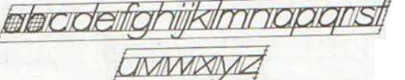

**Figure 3.4: Lower case single stroke inclined method**

**Writing of numbers**

**0 1 2 3 4 5 6 7 8 9**



**Figure 3.5: Numbering using single stroke vertical method**

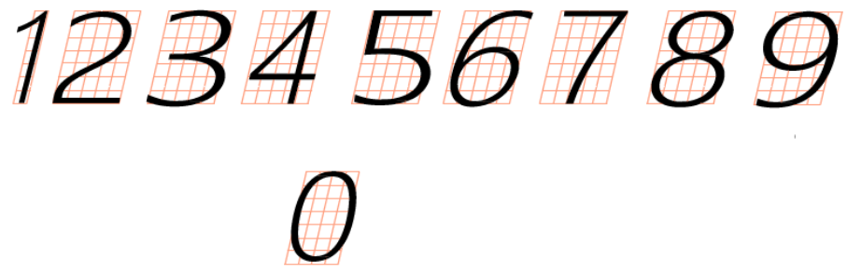

**Figure 3.6: Numbering using single stroke Inclined**

## PC (e) Use numbering and lettering skills in technical drawing.

In our previous lesson we learnt how to prepare to draw, numbering and lettering.

Now, let us use the numbering and lettering skills to complete the title block below. 

**Observation Checklist**

|  |  |  |  |  |  |  |  |
| --- | --- | --- | --- | --- | --- | --- | --- |
| **Learning Outcome 3** | | | **PC (a) – (e)** | | | |  |
| **No** | | **Criteria**  **Based on the specifications given to the Learner by the Assessor** | | **Competence**  **Achieved (A) or**  **Not Achieved (N)** | | |  |
| **A** | **NA** | **Remarks** |  |
| 1 | Ability to select appropriate Symbols and abbreviations | | |  |  |  |  |
| 2 | Could state the importance of Symbols and abbreviation, Numbering and lettering | | |  |  |  |  |
| 3 | Proper usage of Numbers and abbreviations to dimension geometrical figures | | |  |  |  |  |
| 4 | Ability to draw and complete information in the title block | | |  |  |  |  |

# Self-Assessment 3

This learning outcome (LO) has a practical assignment at the end. I recommend you spend time doing the practical on your own. This is meant to help you determine how well you have understood this learning outcome. Now assess yourself with the questions below.

You will be provided with materials, tools and equipment to:

1. Select, from the array, the correct full name for which of the following abbreviation belongs. Insert in the answer column the corresponding number and letter.

|  |  |  |
| --- | --- | --- |
| No. | Abbr, | **Answer** |
| **Example** | Spec | **Specification** |
| 1 | A/F |  |
| 2 | DRG |  |
| 3 | DIA |  |
| 4 | R |  |
| 5 | dm |  |
| 7 |  |  |
| 8 | Ø |  |
| 9 |  |  |
|  |  |  |

|  |  |  |
| --- | --- | --- |
| **ARRAY** | | |
|  | **A** | **B** |
| **1** | **Diameter** | **Drawing** |
| **2** | **Across corners** | **First angle projection** |
| **3** | **Centre line** | **Specification** |
| **4** | **Across flat** | **Radian** |
| **5** | **Millimetre** | **Third angle projection** |
| **6** | **Radius** | **Decimetre** |

2. State **Two (2)** importance of:

a). Symbols and abbreviation

……………………………………………………………………………………………………………………………………………………………………………………………………………………………………………………………………………………………………………………………………………………………………………………………………………………………………………………………………………………………………………..

b). Numbering and lettering

………………………………………………………………………………………………………………………………………………………………………………………………………………………………………………………………………………………………………………………………………………………………………………………………………....

3). i) Use 70mm A/F to dimension the Hexagon shown below

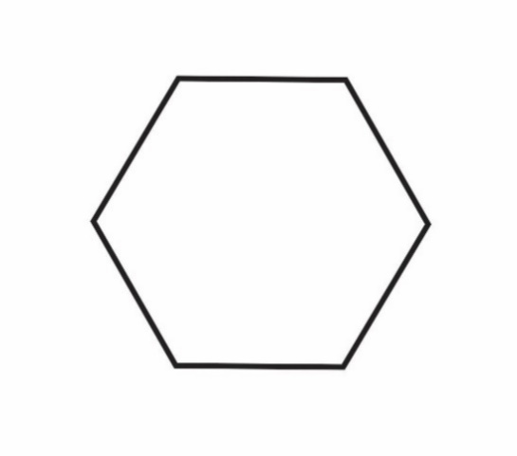

ii) Interpret the symbol 30mm as applied to geometrical object.

………………………………………………………………………………………………………………………………………………………………………………………………………………………………………………………………………………………………………

4.) Draw and complete the following information in a title block:

1. Name
2. School
3. Topic
4. Date.



We believe that you have now acquire skills in explaining symbols, numbers, letters and abbreviations usage in technical drawing. You can explain importance of symbols, numbers, letters and abbreviations in technical drawing, use basic abbreviations and symbols in technical drawing, Practice writing of numbers and letters in technical drawing, Use numbering and lettering skills in technical drawing as per PC’S (a) – (e).

# LO 4. Demonstrate skills in lines, linear measurements, dimensioning and freehand sketching in technical drawing

This LO is developed to help you acquire skills in explaining lines used in technical drawing, explaining linear measurement and dimensioning, applying types of lines used in technical drawing to draw geometrical objects, convert linear measurements, apply principles of dimensioning in geometrical shapes, and use freehand techniques to draw basic geometrical figure with dimensions, as per PCs (a) – (f).

## PC (a). Explain lines used in technical drawing.

In technical drawing, lines are fundamental graphical element used to represent the edges, outlines, and connections of objects, conveying shape, size, and relationships in a precise and standardized manner.

There are two main types of lines used. These are thick continuous and thin continuous lines. A thick continuous line should be about 2-3 times the thickness of the thin continuous line.

**Various types of lines used in general engineering drawing are described below:**

1. **Outlines**: Lines drawn to represent visible edges and surface boundaries of objects are known as outlines or object lines or principal lines. These are represented by continuous thick lines.

2. **Dimension lines**: Are continuous thin lines, used for giving dimensions on drawing. A dimension line is terminated at its outer end with an arrow head touching the outline, extension line or centre line.

3. **Extension lines or projection lines**: These are continuous thin lines used for dimensioning an object. They extend by about 3 mm beyond the dimension lines.

4. **Construction lines**: These are thin continuous lines used as guiding line when drawing objects.

5. **Section lines or Hatching lines**: These are thin continuous lines used for showing the section evidently. They are uniformly spaced thin lines drawn at an angle of 45 degree to the main outline of the section. The spacing between the lines is generally 1 mm to 2 mm.

6. **Leader or pointer lines**: These are continuous thin lines and are drawn to connect a note with the specific feature in the drawing.

7. **Short-break lines**: These are continuous, thin and wavy freehand lines drawn to show the break of an object for a short length. These are also used to show irregular boundaries.

8. **Long-break lines**: these are thin ruled lines provided with short zigzags at suitable intervals. They are drawn to show long breaks.

9. **Hidden or Dashed thin lines**: These are closely and evenly spaced dashes lines of equal lengths. They are of medium thickness and are used to show the invisible or hidden parts of the object on the drawing.

10. **Centre lines**: These are thin, long, chain lines composed of alternatively long and short dashes spaced at an approximate distance of 1 mm. These are used to indicate the axes of cylindrical, conical, spherical objects and centres of circles and arcs.

Centre lines should extend for a short distance beyond the outlines. Extreme positions of movable parts and pitch circles are also shown by these lines.

11. **Cutting-plane lines**: These are long, thin chain line with thick ends. These are used to show the location of cutting plane.

12. **Chain thick:** These lines are used to indicate special treatment on the surface.

13. **Chain thick** **double-dashed**: These lines are used to show outlines of adjacent parts, alternative and extreme positions of movable parts, centroid lines and parts situated in front of the cutting plane.

Table 4.1: below shows the various lines recommended by BS 308 used in technical drawing.

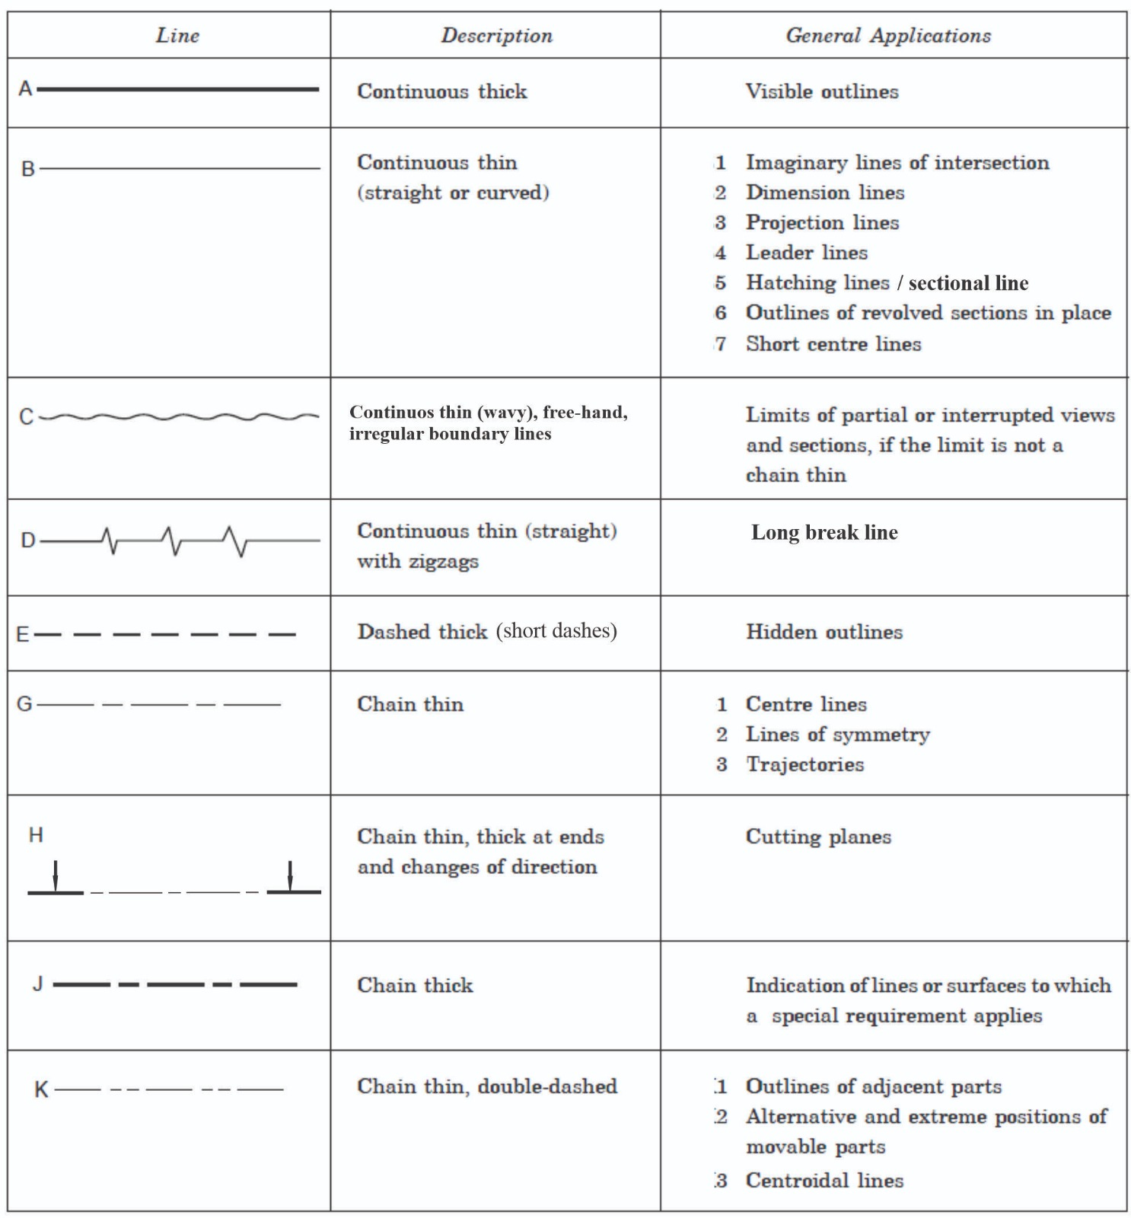

## PC (b) Explain linear measurement and dimensioning.

**Linear measurement** in technical drawing refers to the process of measuring and specifying the length or distance of lines, shapes, or objects represented in the drawing using standardized units such as inches, millimetres, or centimetres, ensuring accurate, and precise dimensioning for construction, manufacturing and other applications.

**Dimension** in technical drawing refers to the representation of the size, shape, and location of objects or features within a drawing using measurements and annotations, providing critical information for understanding and replicating the design accurately

## PC (c) Apply types of lines used in technical drawing to draw geometrical objects.

Have you ever seen the markings on our road network? You will observe that the outer markings are thick continuous lines and the middle being thick long chain line. These communicate to the road users (motorist and pedestrians) how to use the road appropriately.

In this PC, we shall learn how to apply lines in communicating ideas in geometrical objects.

**To draw a cube**

**Steps:**

1. Draw a square and label the corners with letters (a, b, c, d)
2. Draw a continuous thin line at 45˚ to each corner using 45˚ set square and 2H- Pencil.
3. Set the pair of divider at 100mm and mark along each line from corners (a, b, c), and label them (e,f,g.)
4. Use 2H-pencil, join ‘e’ to ‘f’ and ‘f’ to ‘g’.
5. Draw the outline with thick continuous line using the H-Pencil

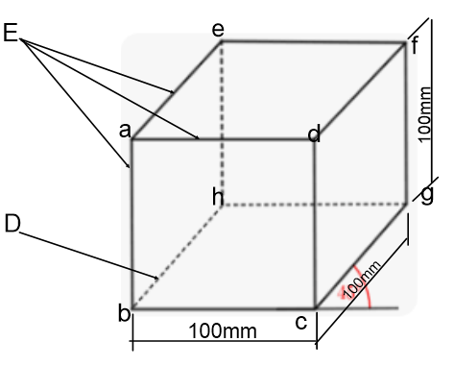

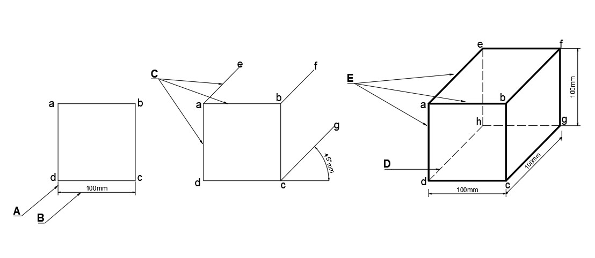

**Figure 4.1: Application of lines to draw a Cube**

IDENTIFICATION OF LINES

A…..Extension / projection line D….. Short dashes (hidden edge)

B…..Dimension line E…..Continuous thick line (outline)

C…..Continuous thin (constructional) line

**To draw a triangular prism**

**Steps:**

1. Draw a right- angled triangle (and label each corner ( a,b , c).
2. Draw a continuous thin line at 45˚ to each corner using 45˚ set square and 2H-Pencil.
3. Set the pair of compasses at 120mm and mark along each line from corners (a, b, c) and label the marks (e,f,g)
4. With 2H- Pencil, join e to ‘f’ and f to ‘g’
5. Draw the outline with thick continuous line using the H-Pencil
6. Measure 40mm from ‘a’ along line ‘ab’ and draw line P-P (cutting plane).
7. Draw sectional line to show cut surface.

**Figure 4.2: Application of lines to draw Triangular prism**

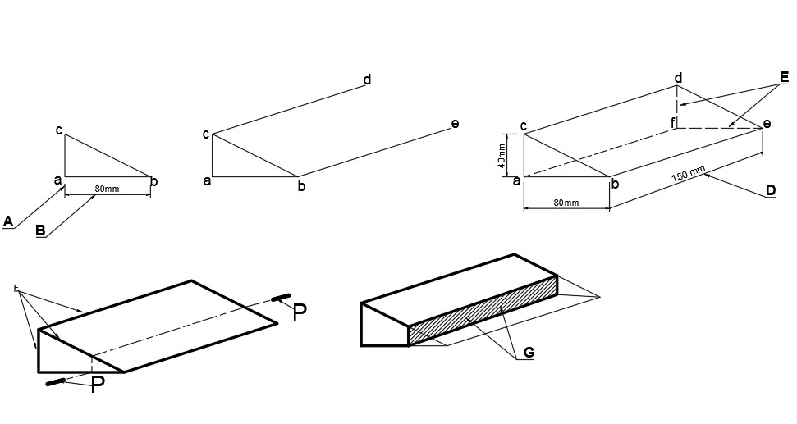

**IDENTIFICATION OF LINES**

A…… Extension/ projection line E …… Short dashes (hidden lines)

B……. Dimension line G …… Sectional lines

D… Dimension line P-P ……Cutting plane

To draw a cylinder

**Steps:**

1. 1, Draw an isometric axes (A, O, B) from point ‘O’ using 30˚ set square and a Tee-Square
2. Draw a continuous vertical thin lines from A and b using 2H-Pencil, 30˚ set square and tee square
3. Mark along each line from corners (A, O, B,), and label the marks (C, D, E.)
4. Join point Cot D and D to E using 30˚ set square in conjunction with a Tee- square.
5. Draw a parallel lines to lines CD and DE from points E and C respectively to meet at F.
6. Divide square AOBG and CDEF into halves.
7. Join point D to 1 and 2, F to 3 and 4
8. With X as centre open to 1 and draw an arc to meet 4
9. With Y as centre open to 2 and draw an arc to meet 3.
10. With D as centre open to 1, draw an arc to join 2. Also with F as centre open to 4 and draw an arc to meet 3
11. Repeat steps 8,9,10, and 11 at the base (AOBG)
12. Draw a tangent to the isometric circles to obtain the required cylinder.

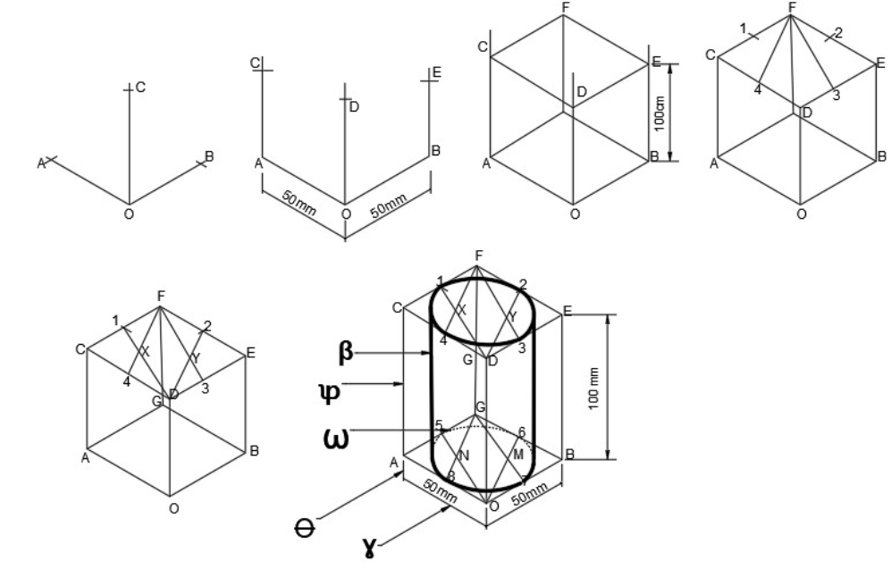

**Figure 4.3: Application of lines to draw a cylinder**

**IDENTIFICATION OF LINES**

β…….Continuous thick ( 0utline)

φ…….Continuous thin ( constructional line)

Ꞷ……Short dashes (hidden lines)

ϴ…..Projection/ Extension line

Ɣ…..Dimension line

**To draw a cone**

**Steps:**

1. Draw an isometric axes (A, O, B) from point ‘O’ using 30˚ set square and a Tee-Square
2. Draw a continuous vertical thin lines from a and b using 2H-Pencil, 30˚ set square and tee square
3. Mark along each line from corners (A, O, B,), and label the marks (C, D, E.)
4. Join point C to D and D to E using 30˚ set square in conjunction with a Tee- square.
5. Draw a parallel lines to lines CD and DE from points E and C respectively to meet at F.
6. Divide square AOBG and CDEF into halves.
7. Join point D to 1 and 2, F to 3 and 4
8. With X as centre open to 1 and draw an arc to meet 4
9. With Y as centre open to 2 and draw an arc to meet 3.
10. With D as centre open to 1, draw an arc to join 2. Also with F as centre open to 4 and draw an arc to meet 3
11. Draw a tangent from H to the isometric circle to form the require cone

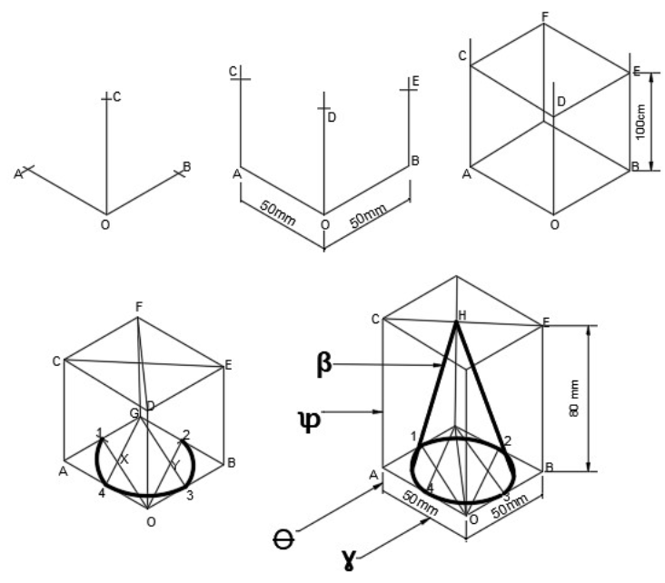

**Figure 4.4: Application of lines to draw a cone**

β…….Continuous thick ( 0utline)

φ…….Continuous thin ( constructional line)

ϴ…..Projection/ Extension line

Ɣ… Dimension line

The figure below shows orthographic views of a wooden block. Let us observe carefully and identify how types of lines are applied.

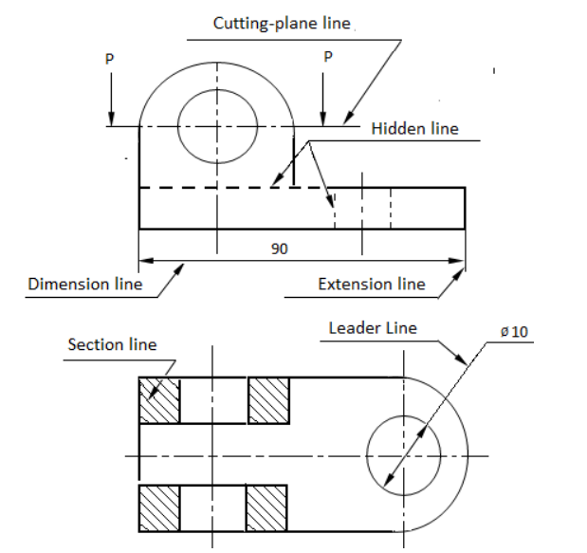

**Figure 4.5: Application of line on Geometrical figure**

## PC (d) Convert linear measurements.

Have you ever used ruler or tape measure at a workplace? The measurements taken by these instruments is called linear measurement and are in either metric or imperial. In this PC, we shall look at conversions between linear metric measurements, metric to imperial and vice versa.

**METRIC MEASUREMENT**

Linear measurement basically is a measurement taken between two lines or points. Length has its standard international (SI) unit as Metre. However, metre can be converted to other units but we shall convert from;

1. Millimetre (mm) to Centimetre (cm)
2. Millimetre (mm) to Metre (M)
3. Metre (M) to Kilometre (km)

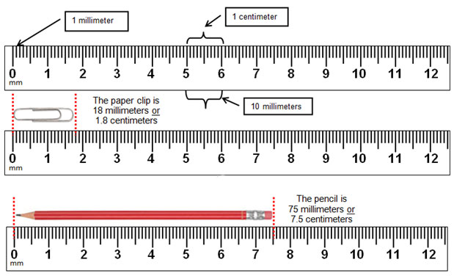

**Figure 4.6: Metric Rule**

**Metric**

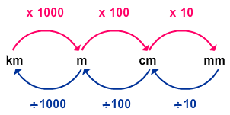

Figure 4.7: Conversion in metric units

**Note**

1cm = 10mm

1M = 100cm

1M = 1000mm

1km = 1000M

**Rule**

Changing from **bigger** unit to **smaller** unit (**multiply**)

Changing from **smaller** unit to **bigger** unit (**divide**)

Let’s try these examples:

**Changing from centimetre to millimetre**

1. Convert 500cm into mm

**Solution**

Centimetre (cm) is **bigger** than millimetre (mm) therefore we shall **multiply**

**Note:**

10mm=1cm

Therefore we shall multiple 500 by **10**

Thus (500×10) = **5000mm**

**This implies that 500cm= 5000mm**

**Changing from millimetre to metre**

2. Convert 1500mm into m

**Solution**

Millimetre (mm) is **smaller** than meter (M) therefore we shall **divide**

**Note** 1000mm=1M

Therefore we shall divide by **1000**

Hence (1500÷1000) = 1.5m

This implies that **1500mm=1.5m**

**Changing from metre t kilometre**

1. Convert 6980m into km

**Solution**

Metre (m) is **smaller** than kilometre (km) therefore we shall **divide**

**Note**:

1km=1000m

Therefore we shall divide with **1000**

Hence (6980÷1000) = 6.98km

This implies that **6980m=6.98km**

**IMPERIAL SYSTEM OF MEASUREMENTS**

Table 4.1 **STANDARD TO METRIC CONVERSION**

|  |  |
| --- | --- |
| 1 mile=1.61 kilometers | 1mi = 1.61km |
| 1 mile=1609.34 meters | 1mi =1609.34m |
| 1 yard=091 meters | 1yd = 0.91m |
| 1 yard=91.44 centimeters | 1yd = 91.44cm |
| 1foot=30.48centimeter | 1ft = 30.48cm |
| 1 inch=2.54centimeters | 1in = 2.54cm |

**METRIC TO STANDARD CONVERSION**

|  |  |
| --- | --- |
| 1 Kilometer = 0.62 miles | 1km = 0.62mi |
| 1 Kilometer =1093.61 yards | 1km = 1093.61yd |
| 1 meter=1.09yards | 1m = 1.09yd |
| 1meter =3.28feet | 1m = 3.28ft |
| 25.4 millimeter=1 inches | 25.4mm = 1 in |

Imperial system of measurement is an old British system of measurement. We shall consider conversion of unit in the linear measurement (length) thus from imperial to metric and vice versa. We shall limit ourselves to conversion from;

Millimetres (mm) to inches (inch)

Millimetres (mm) to metres (M)

Centimetres (cm) to inches (inch)

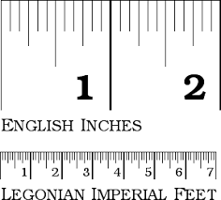

**Figure 4.8: Imperial Rule**

**Note**

1 inch =2.54cm

1 foot= 30.48cm

1 mile= 1.609km

**Rule**

Changing from **bigger** unit to **smaller** unit (**multiply**)

Changing from **smaller** unit to **bigger** unit (**divide**)

Let us try these examples;

**Conversion from centimetres (cm) to inches (inch)**

1, Convert 109cm into inch

**Solution**

Centimetre (cm) is smaller than inch therefore we shall **divide.**

Note 1 inch = 2.54cm

Therefore we shall divide with **2.54**

Hence (109 ÷ 2.54) = **42.91** inch

This implies **that 109cm=43** inches

**Conversion from millimetres (mm) into inches (inch)**

**2. Convert 300mm into inch**

**Solution:**

**METHOD 1**

Millimetre (mm) is smaller than inch (in) therefore we shall **(divide)**

**Note:**

1in = 25.4mm

Therefore we shall divide with **25.4**

Hence (300÷ 25.4) = **11.81 inch**

**This implies that 300mm = 11.81 in**

**METHOD 2**

**STEPS;**

1. first Change millimetre to Centimetre
2. Secondly change the answer in centimetre to inch

Now let solve the question

**300mm into inch**

Note

Changing from millimetre to centimetre **(divide**)

1 cm=10mm

Therefore we shall divide by **10**

Hence (300÷10) = **30cm**

We shall now convert the answer 30 **centimetre to inch**

Note 1 inch= 2,54cn

Changing from centimetre to inch (**divide**)

Hence (30 ÷ 2.54) = 11.81inch

This implies **300mm =** **11.81 inch**

**Conversion from millimetre (mm) into feet (ft.)**

3. Convert 600mm into feet.

***CLUE***

***SINCE YOU CANNOT CHANGE IT DIRECT, FOLLOW THE STEPS BELOW;***

1. first Change the unit from millimetre to centimetre
2. Secondly, change the answer in centimetre to feet.

Now let’s solve the question

**600mm into ft**

Note

Changing from millimetre to centimetre **(divide**)

1 cm=10mm

Therefore we shall divide by **10.**

Hence (600 ÷ 10) = **60cm**

Now change the answer 60 centimetre into foot.

1 foot = 30.48cm

Changing from centimetre into foot (**divide**)

Hence (60 ÷30.48) = **1.97 ft**

This implies **600mm $=$ 2 ft**

## PC (e). Apply principles of dimensioning in geometrical shapes.

PRINCIPLES OF DIMENSIONING

Dimensioning is a fundamental aspect of technical drawing and design documentation. It involves providing correct information about the size, location, and relationships of various features and components within an engineering or architectural design. The principles of dimensioning serve as guidelines to ensure that these drawings convey information accurately and comprehensibly to those involved in manufacturing, construction, or other related field.

PRINCIPLES

Types of lines used in dimensioning

Lines use in dimensioning;

1. Extension/projection
2. Leader line
3. Dimension line

PRINCIPLES OF DIMENSIONING

The following are some of the principles and recommendations in dimensioning;

1. Projected or extension lines should be 1mm to 2mm away from the outlines of the object.
2. Dimension lines should be placed outside the outline of the object.
3. Arrow heads should be easily readable and should be between 3mm to 4mm long
4. Leader lines should be drawn at a convenient angle not less than 30º but often 45º from the object.
5. Number or letters should be placed at the middle of the dimension lines
6. Numbers or letters should be placed a little above the dimension and must not be crossed or separated by any other line.
7. Numbers and letters should be legible for easy reading and must be perpendicular to the dimension lines.
8. Shorter dimension lines should be closer to the outline of the object in case there are several parallel dimension lines.
9. Place dimension lines about 10mm away from the object.
10. Avoid duplicate dimensioning.
11. The symbol of diameter (Ø) of circle should precede the figure but not the radius (R).
12. Dimensions which are not drawn to scale should be underlined.
13. Dimensions should be lettered in one unit only. Example, 65.5m and not 65metres and decimetres (i.e. 65m, 5dm)
14. Never use plural to denote lengths. E.g., 100metres and not 100ms
15. Where a note such as ‘All dimensions are in millimetres’ is given on drawing the unit after which each dimension is omitted.

**Application of the principles of dimensioning**

**The following drawings show application of principles of dimensioning objects.**

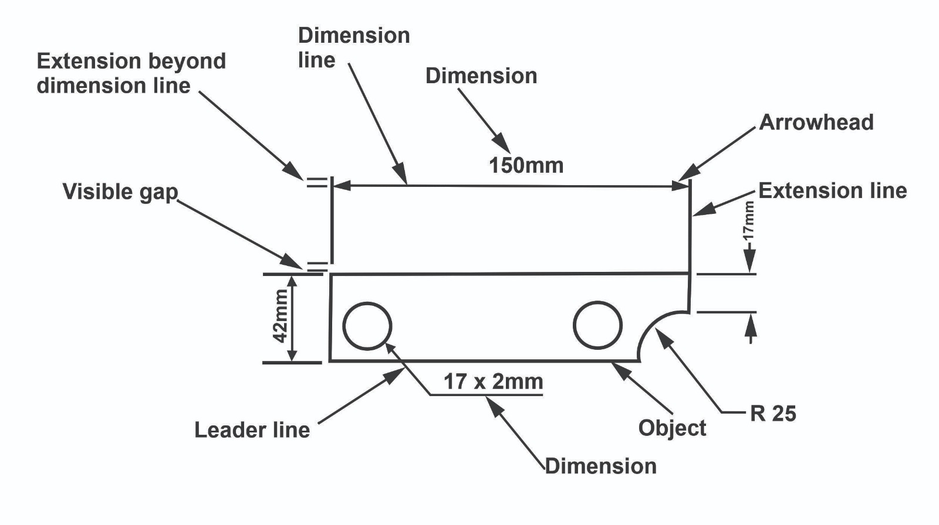

**Figure 4.9: Features of Dimensioning**

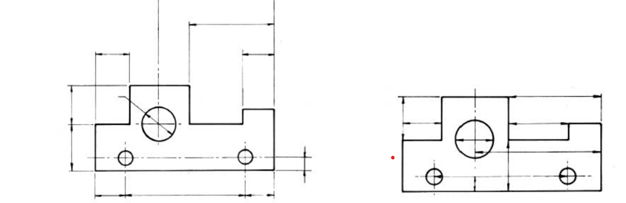

**Figure 4.10 a: Correct Method of Dimensioning Figure 4.10b: Incorrect Method of Dimensioning**

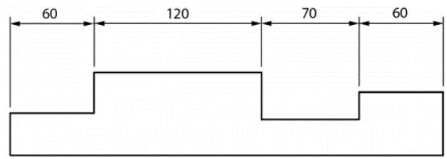

Figure 4.11: Chain Dimensioning

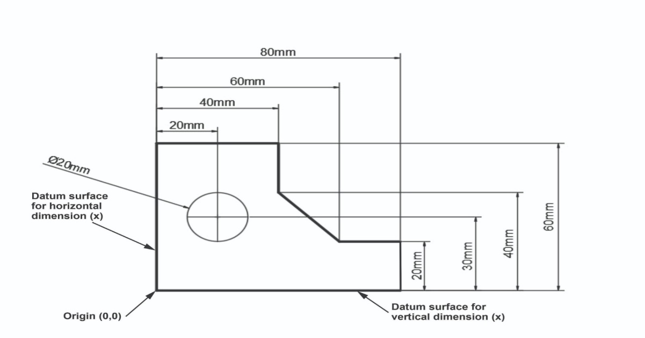

**Figure 4.12: Datum Dimensioning**

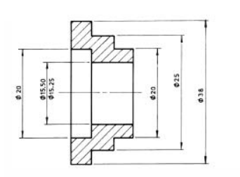

Figure 4.13: Staggered Dimensioning

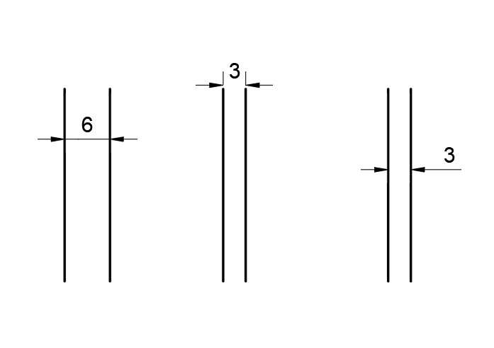

**Figure 4.14: Dimensioning Small Features**

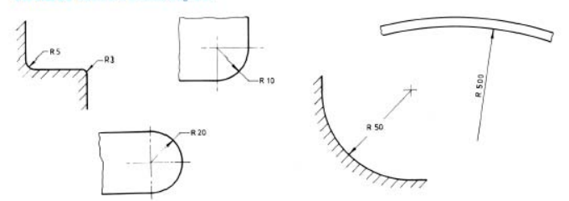

**Figure 4.15: Methods of Dimensioning Radius**

**Fig. Method of dimensioning diameter**

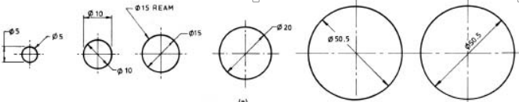

Figure 4.16: Method of Dimensioning Diameter

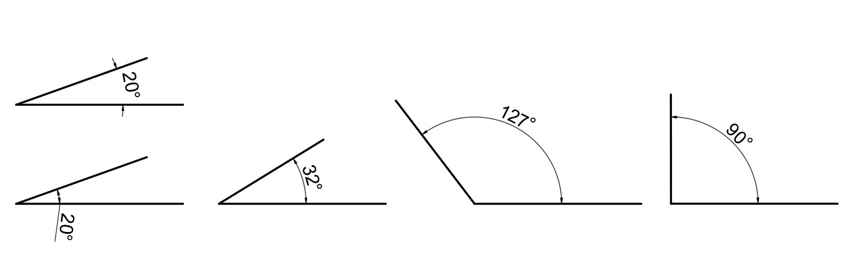

**Figure 4.17: Method of Dimensioning Angles**

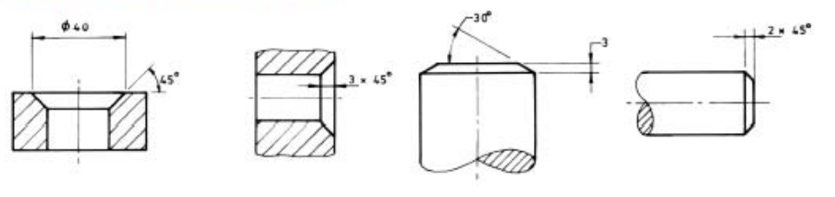

Figure 4.18: Method of Dimensioning Chamfer

## PC (f). Use freehand techniques to draw basic geometrical figures with dimensions.

Have you ever seen artists drawing magnificently without using any tools but a pencil and their skill? If yes, then always admired them. Ability to do this is called freehand sketch, but what is it all about?

Freehand sketching is a rapid, essential step in early design, commonly used in manufacturing. Designers rely on it for brainstorming and creativity. These sketches are hand-drawn without precise tools, emphasizing speed and convenience, estimating proportionality, resemblance and clarity. It involves various styles, including Three-Dimensional or pictorial (isometric, oblique, perspective) and Two-Dimensional drawing (orthographic projection).

All you need is an HB pencil and an eraser. Grid papers are sometimes used as a helping aid for learners who find sketching difficult. It is a flexible and accessible means of visually expressing ideas. The grid papers could be 4, 5, 8 squares per 25mm.

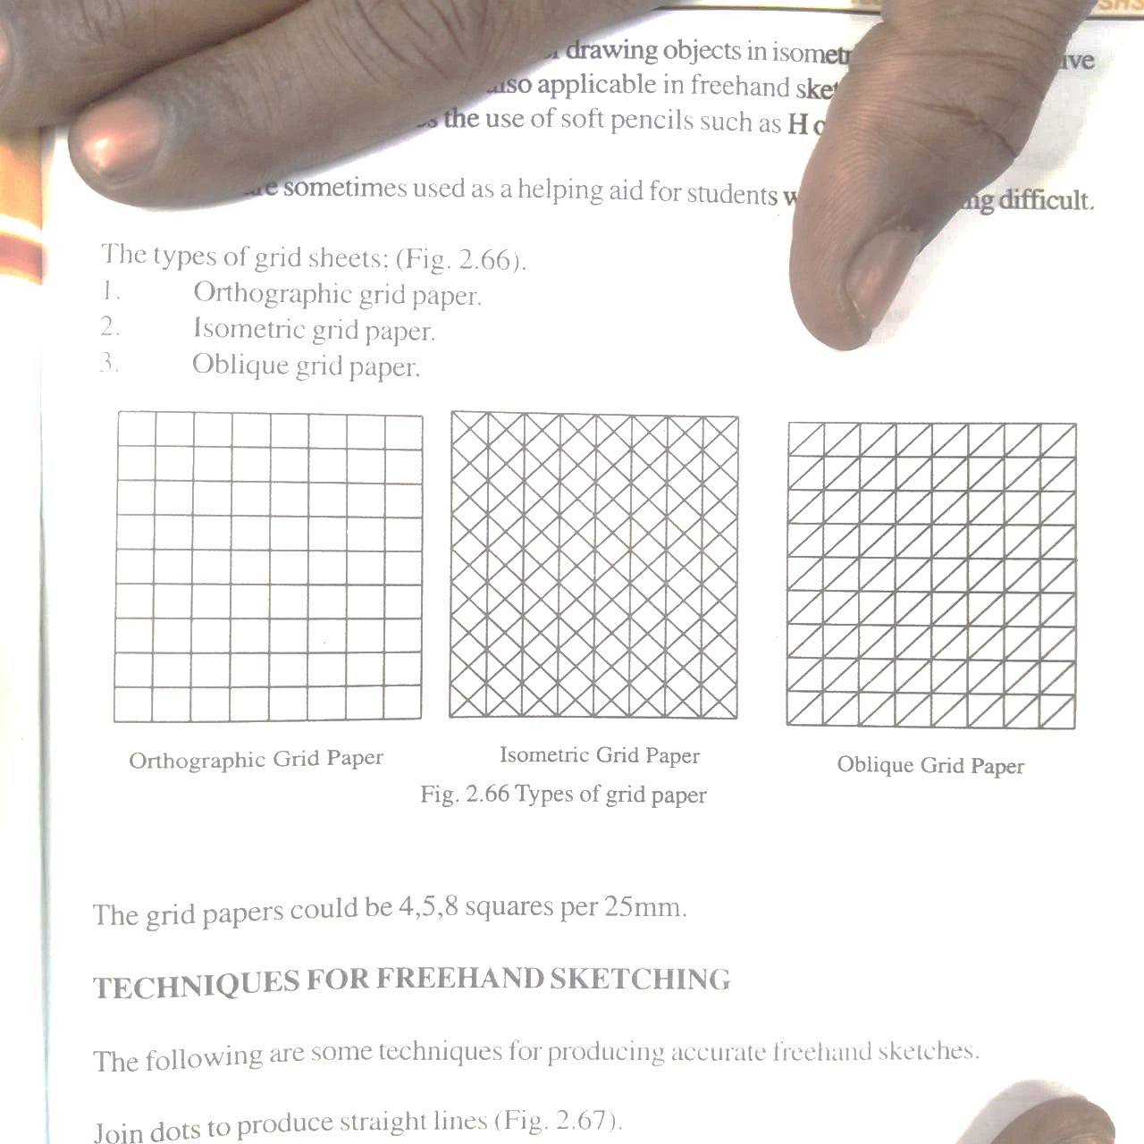

**Figure 4.19: Types of Grid Papers**

**Techniques in freehand sketching**

* 1. Proportionality
  2. Resemblance
  3. Positioning of the drawn object.
  4. Quality of lines
  5. Hand-eye coordination
  6. Pictorial in nature

The above techniques must be noted when making a freehand sketches

Procedure use to make freehand sketching of solid geometry

Step:

1. Draw with the pencil held slightly above the conical point, join the dots with free and flexible wrist and arm movement.
2. Keep an eye on the dots but not on the pencil point as you draw to join whilst moving the wrist and the arm gently.

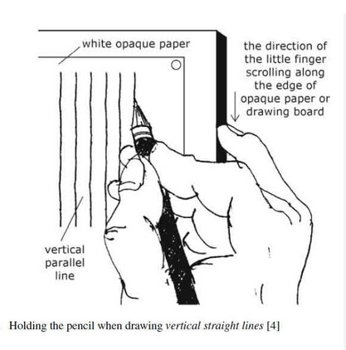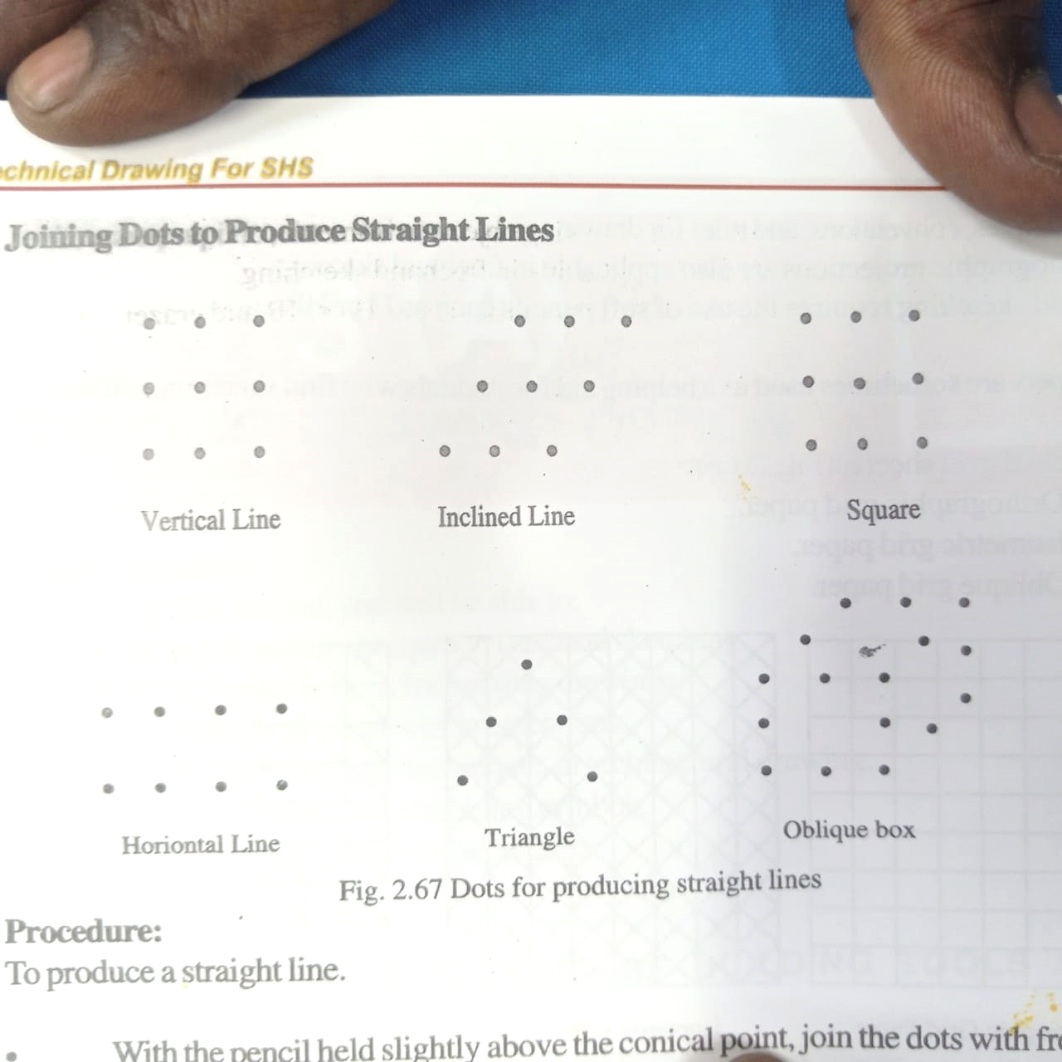

Vertical line

**Figure 4.20: Joining Dots to Produce Vertical Lines**

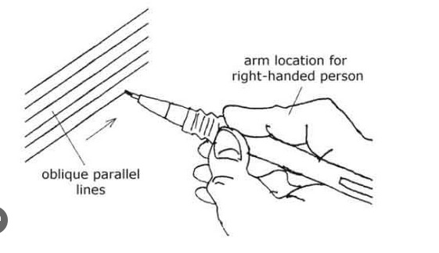

Inclined line

**Figure 4.21: Jointing Dots to Produce Inclines Lines**



Horizontal line

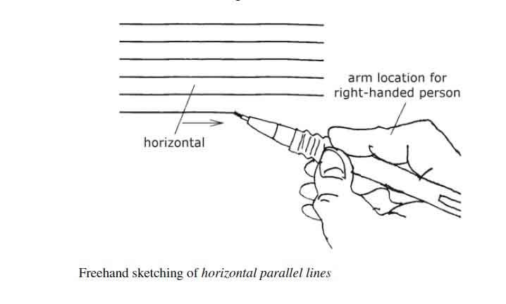

**Figure 4.22: Joining Dots to Produce Horizontal Lines**

Using square method to produce a circle

***Step:***

1. Draw the required square.
2. Locate points 1,2,3 and 4 at the mid points of each of the four sides
3. Join diagonals of the square to obtain the centre O
4. Join with free hand, the points 1,2, 3 and 4 to complete the circle.

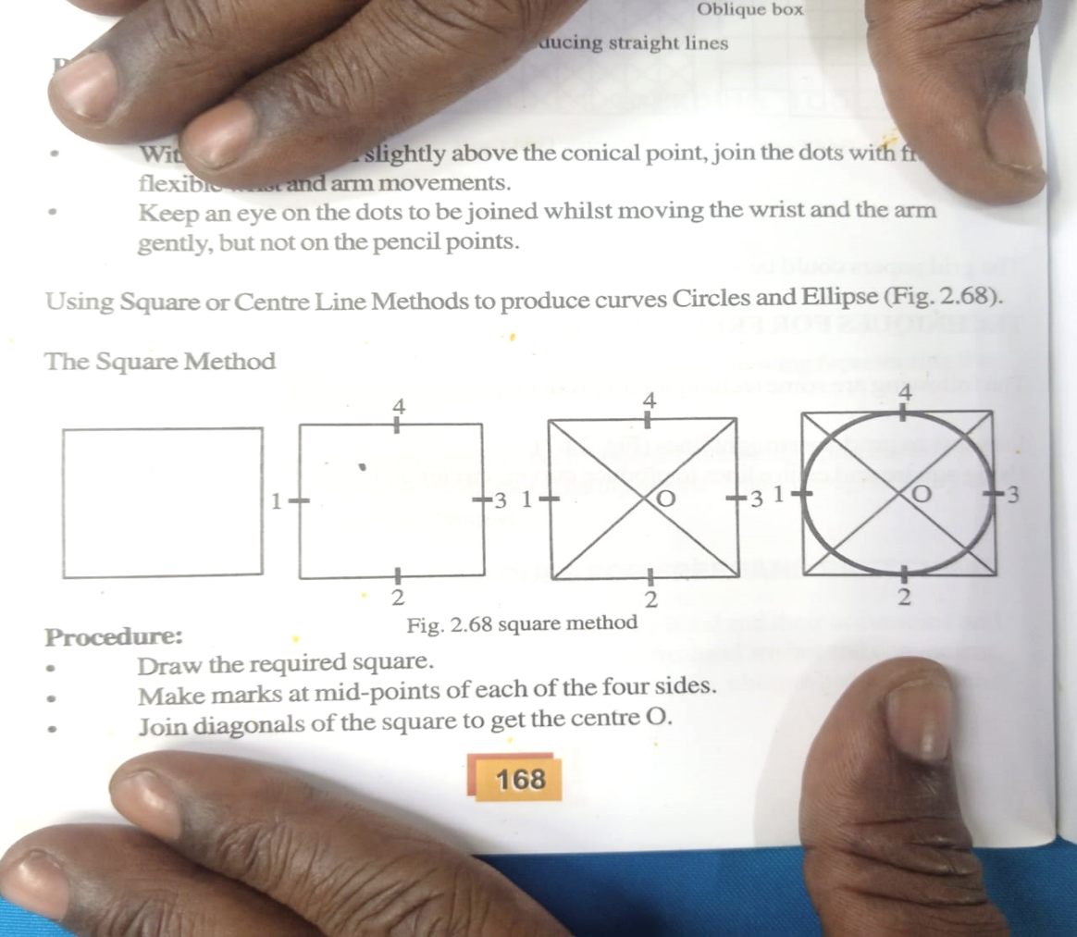

Figure 4.23: Using a Square to Produce a Circle

***Using the Centre Line Method to Produce a Circle***

***Steps:***

* 1. Draw horizontal and vertical centre lines required.
  2. Draw two or more radial lines through the centre
  3. Locate the points on the radial lines proportionally.
  4. Draw a smooth curve through the points to obtain the circle.

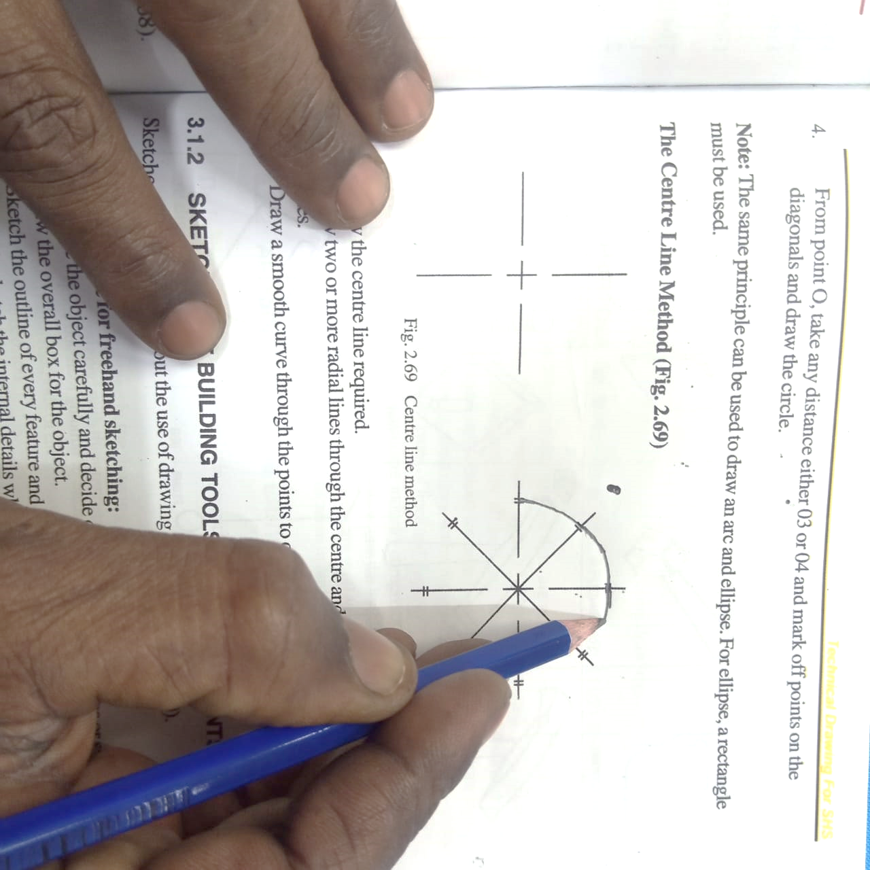

**Figure 4.24: Using Centre line method to draw a Circle**

Based on what we have practiced, let us follow the steps to make a freehand sketch of the geometrical figures below.

**CONE**

**Steps:**

1. Draw the Square A, B, C and D in Isometric
2. Mark their mid –point 1, 2, 3 and 4
3. Join point B4, D2, D1 and B3
4. Join point 1, 2, 3 and 4 with a free hand to complete the Isometric circle
5. Erect vertical lines from points A, B, C and D to a convenient height
6. Join the points to form the top at E, F, G and H
7. Draw the diagonal to locate the mid-point X
8. Draw a line from point X to touch the circumference at both ends

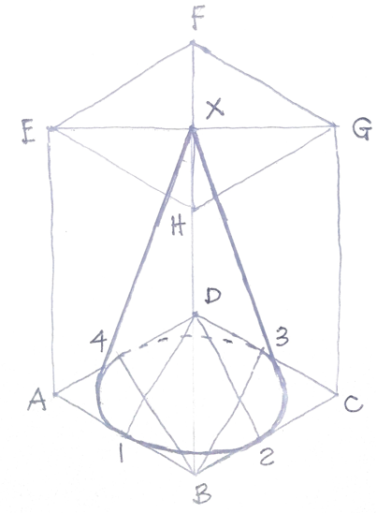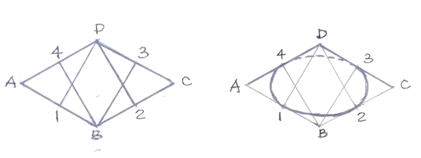

Figure 4.25 freehand sketch of a cone

**CYLINDER**

**Steps:**

1. Draw the square ABCD in isometric.
2. Mark their mid-points, 1, 2, 3 and 4.
3. Join points B4, D2, D1 and B3
4. Erect vertical lines from points A, B, C and D to a convenient height at E, F, G and H
5. Join points E, F, G and H and locate their mid-points 1, 2, 3 and 4.
6. Join points 1 to F, 2 to F, 3 to H, and 4 to H.
7. Join points 1, 2, 3, and 4 to complete the circles
8. Join the ends with vertical line, tangentially to complete the cylinder as shown in Fig. 4.26

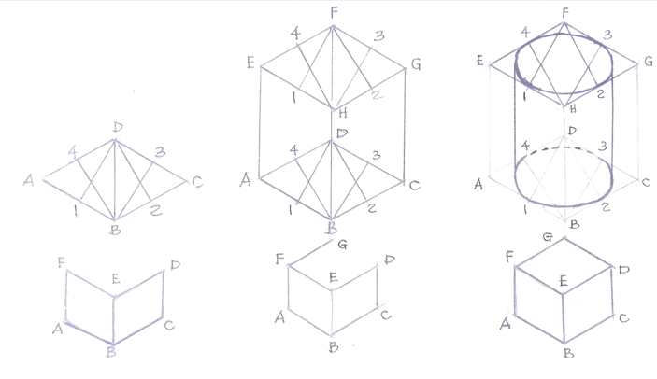

**Figure 4.26 freehand sketch of a cylinder**

**Freehand Sketch of a Cube**

**Steps:**

Draw inclined line AB and BC

Erect vertical lines from A, B and C to F, E, and D

Join line F to G and E to D

Draw a line from G to D to complete cube as shown in Fig. 4.27



**Figure 4.27 free hand sketch of a cube**

**TRIANGULAR PRISM**

**Steps:**

1. Draw the ABC
2. Draw vertical lines from points ABC to a convenient height D, E and F
3. Join points D to E and E to F
4. Join D to E with a hidden line to complete the triangular prism

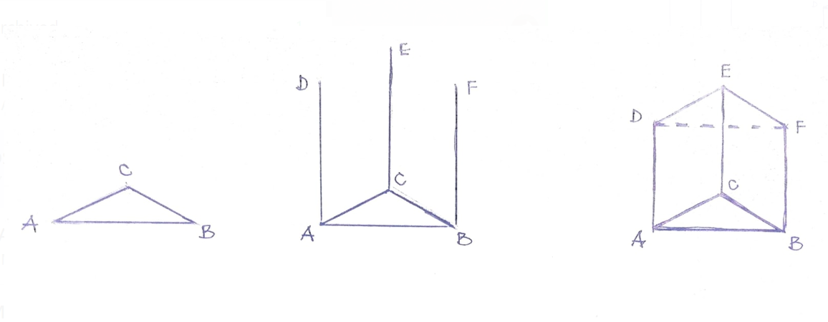

**Figure 4.28 free sketch of a triangular prism**

**Observation Checklist**

|  |  |  |  |  |  |  |
| --- | --- | --- | --- | --- | --- | --- |
| **Learning Outcome 4** | | **PC (c) – (f)** | | | |  |
| **No** | **Criteria**  **Based on the specifications given to the Learner by the Assessor** | | **Competence**  **Achieved (A) or**  **Not Achieved (N)** | | |  |
| **A** | **NA** | **Remarks** |  |
|  | Correct usage of the following lines:   1. Outline 2. Continuous thin (constructional line) 3. Projection/ extension line 4. Dimension line | |  |  |  |  |
|  | Appropriate conversion of units from Imperial to metric and vice versa | |  |  |  |  |
|  | Ability to apply lines correctly to draw a cylinder. | |  |  |  |  |



# Self-Assessment 4

This learning outcome (LO) has a practical assignment to help you master the skill in lines, linear measurement, dimensioning and freehand sketching. I recommend you to spend time and do the practical assignment to help you determine how well you have understood this learning outcome. Now assess yourself with the practical questions below.

You will be provided with equipment and materials to:

1, State **ONE (1)** use each of the following lines

1. Continuous thin line
2. Chain thick line

………………………………………………………………………………………………………………………………………………………………………………………………

……………………………………………………………………………………………………………………………………………………………………………………………………..

2. Explain the following terms

1. linear measurement
2. Dimensioning

………………………………………………………………………………………………………………………………………………………………………………………………………………………………………………………………………………………………………..

…………………………………………………………………………………………………

1. Apply the type of lines used in technical drawing to draw a cylinder.

4. Convert the following units

i). 8156mm into metre (m)

ii) 450M into Centimetre (cm)

iii) 6738mm into feet (ft)

……………………………………………………………………………………………………………………………………………………………………………………………………………………………………………………………………………………………………………………………………………………………………………………………………………………………………………………………………………………………………………………………………………………………………………………………………………..

1. Apply the principles of dimensioning to dimension the diagram below;
2. Overall length.
3. Use leader line to dimension the following:
4. Outer circle
5. Semi-circle at the right hand side.

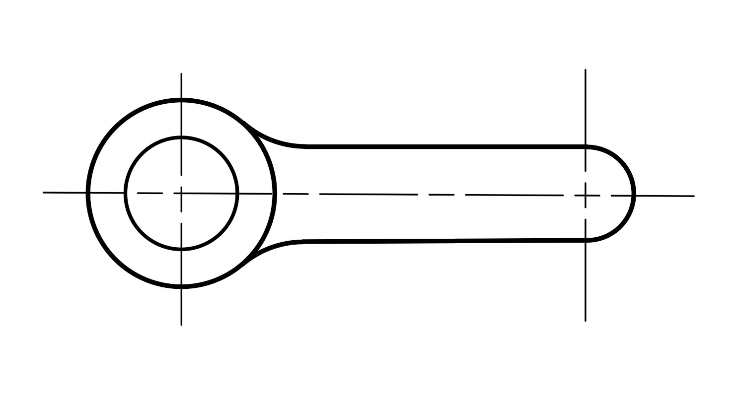

1. Make a freehand sketch of a cone



We believe you can now explaining lines used in technical drawing, explain linear measurement and dimensioning, apply types of lines used in technical drawing to draw geometrical objects, convert linear measurements, apply principles of dimensioning in geometrical shapes, and use freehand techniques to draw basic geometrical figure with dimensions, as per PC’s (a) – (f).

# LO 5 Demonstrate skills in plain and diagonal scales

This LO is developed to help you acquire skills in explaining**,** Scales, State reasons forusing scales, differentiate between plain and**,** Diagonal scales, draw scales in metric unit, draw basic geometrical figuresusing diagonal and plain scales as per PCs (a) – (e).

## 

## PC (a) Explain Scales

The work of the draughtsman may entail drawing objects, which are either big or small. In some instances, the actual size of the object is far larger than the size of the paper to be used. Example, buildings, bridges, large equipment and machines. In some other instances, the actual size of the part is so small that it is difficult to draw using the actual sizes.

A scale is referred to as a proportional relationship between dimension of a drawing and the actual object or structure. It is normally represented as a ratio known as a representative fraction (RF). Scale can be expressed in the following three ways:

i). Full size scale. ii). Reducing scale iii). Increasing scale

**Full size scale:**

If actual dimension of an object is shown in the drawing, then the scale used is said to be full size scale.

It can be represented as 1cm=1cm (1cm: 1unit)

**Reducing scale**

This scale is represented as for example, 1cm=2m. This indicates that the linear dimension of 2m of an actual object is represented by 1cm on the drawing of the object.

**Increasing or enlarging scale**

This scale is represented as for example, 1cm=1mm. This indicates that the linear dimension of 2mm of an actual object is represented by 1cm in the drawing of that object.

**Representative Fraction (R.F.)**

Representative Fraction (R.F.) is the ratio of drawing size of an object to its actual size.

This is another method of representing scale.

For reducing scale, the R.F. value is less than unity (one). Example 1/2

For enlarging scale, the R.F. value is greater than unity (one). Example 3/2

For full size scale, the R.F. value is equal to unity (one). Example 2/2

**Plain Scales**

A plain scale is simply a line, which is divided into a suitable number of equal parts of which one part is sub-divided into ten units.

This is used to represent either two units or a unit and its fraction such as metre and decimetre, kilometre and hectometre.

**Construction of Plain Scales**

To construct a plain scale the following information are required.

1. R.F. of scale to be constructed
2. Maximum length to be measured
3. Divisions to be drawn

**Diagonal Scales**

Diagonal scale has three sets of divisions which provide three units of measurements (i.e. m, dcm, cm) to read to the accuracy of two decimal places.

**Principle of Diagonal Scale**

1. It consists of a line divided into required number of equal parts.
2. The first part is sub-divided into ten equal parts and further divided into another ten equal parts by drawing diagonals.

## PC (b) State reasons for scaling

The following are the reasons for scaling:

**Size Adjustment:** This is a scaling process of changing the dimensions of an object or image while maintaining its proportions, whether you are enlarging (scaling up) or reducing (scaling down).

**Measurement and Precision**: Measurement and precision in scaling involve accurately determining real-world dimensions from scaled representations and ensuring that those representations closely match the original objects or spaces.

**Proportion and Comparison**

Proportion and comparison are super important in scaling because they make sure that when we reduce or enlarge things on paper or in models, they still look like the real things in terms of size and how they relate to each other.

**Convenience**: Convenience in scaling means resizing or representing objects, drawings, or models makes it more user-friendly, efficient, and easy to work with. It involves designing the scaling process or tools to be practical and accessible for user consistency.

**Cost-efficiency:** Cost-efficiency in scaling refers to resizing or representing objects, drawings, or models while reducing expenses and resources associated with it.

## PC (C) Differentiate between plain and diagonal scales,

The difference between plain and the Diagonal Scale are outlined in the table below:

Table 5.1

|  |  |
| --- | --- |
| **PLAIN SCALE** | **DIAGONAL SCALE** |
| It has two divisions to represent two set unit of measurement. | It has three divisions to represent three set unit of measurement. |
| It provides less degree of accuracy in reading.  It is not a versatile scale for representing a range of values. | It provides more accurate reading in linear measurement.  More versatile scale for representing a range of values. |
| It is usually used for drawing maps. | It is used on small features and Engineering component |

**PC (d) Draw Scales in Metric Unit.**

**To draw a plain scale of 30mm to 1m to read up to 5m**

Take the following reading on the scale

1.6m (2) 2.4m (3) 3.8m

Steps:

1. Draw a line AB
2. Erect a perpendicular at A and B
3. Mark a convenient height at C and D
4. Join point CD to complete a rectangle
5. Divide line AE into 10 equal parts
6. Project vertical lines from the divisional points to C0
7. Take the reading as shown.

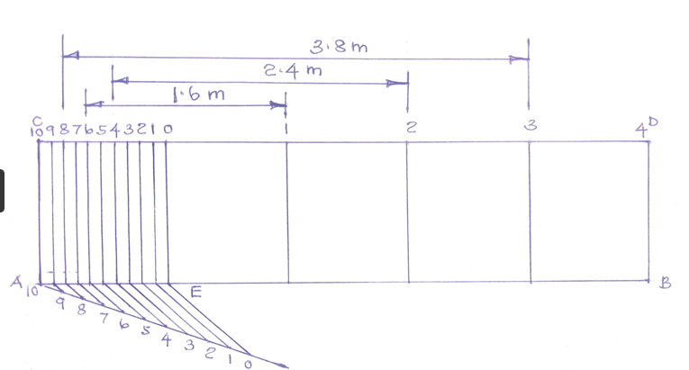

**Figure 5.1: Construction of Plain Scale**

**To draw a Diagonal scale of 30mm to 1m to read up to 5m**

To Construct a Diagonal Scale 45mm to 1metre to read up to 3 metres. Indicate in metres the following readings:

1. 2.89m
2. 1.67m
3. 2.67m
4. 2.34m
5. 1.34m

**STEPS**

1. Draw line AB 135mm long
2. Draw a perpendicular line AC to any convenient height to form a rectangle ACDB.
3. Divide rectangle ACDB into Three (3) units
4. Divide line A0 into 10 equal parts and draw diagonal lines from each of the divisions to meet line CD
5. Divide line AC into 10 equal parts and draw horizontal lines to line 0.
6. Take your readings as shown in the diagram below.

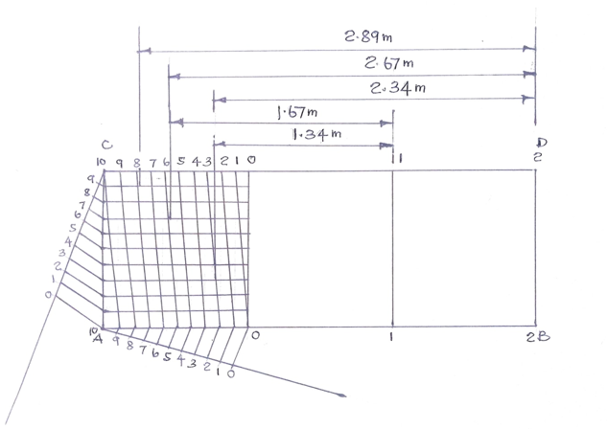

**Figure 5.2: Construction of Diagonal Scale**

## PC (e) Draw Basic Geometrical Figures Using Diagonal and Plain Scales

1a). Construct a diagonal scale, 10cm=1dm to read up to a maximum of 2dm

1b). Using the readings on the scale, construct triangle ABC, with AB 1.74dm, BC 1.38dm and AC 1.10dm.

**NOTE**

Full size = 2dm

10cm=1dm

This implies (10cm ×2) = 20cm

**Steps:**

1. Draw line AB 20cm long
2. Draw a perpendicular line AC to any convenient height to form a rectangle ACDB.
3. Divide rectangle ACDB into two (2) units
4. Divide line AE into 10 equal parts and draw diagonal lines from each of the division to meet line CD
5. Divide line AC into 10 equal parts and draw horizontal lines to line E.
6. Take your readings as shown in the diagram below.

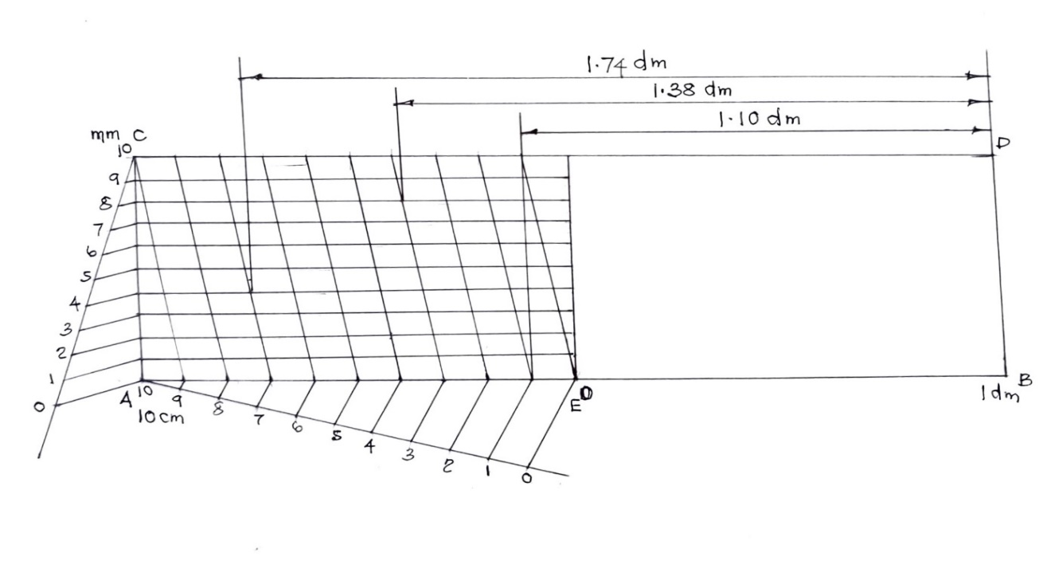

**Figure 5.3: Construction of Diagonal Scale**

**b) Construction of Triangle ABC**

**Steps:**

1. Measure and draw line AB=1.74dm.
2. At A, and a distance of 1.38dm, construct an arc
3. At B, and a distance of 1.10dm, construct an arc to intersect at C.
4. Join AC and BC to complete the triangle as shown below.

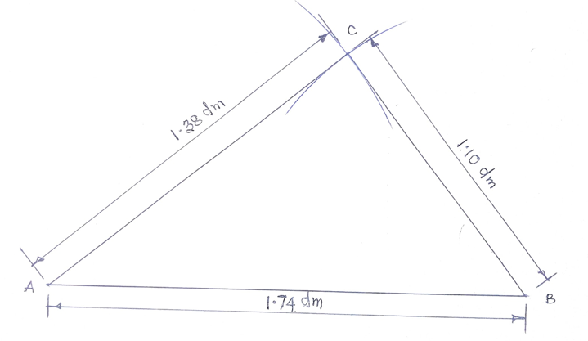

Figure 5.4 construction of a triangle from a scale

**2). Construct a rectangle ABCD using the plain scale in Figure 5.1 with side AB = 2.4m and side AD = 1.6m**

Step:

1. Draw line AB with the length 2.4m
2. Construct a perpendicular at A
3. Measure 1.6m from the scale and mark it on the perpendicular line from A to D
4. At D, measure 2.4m from the scale and construct an arc.
5. At B, measure 1.6m and construct another arc to intersect the previous arc at C
6. Join point DC and BC to complete the rectangle

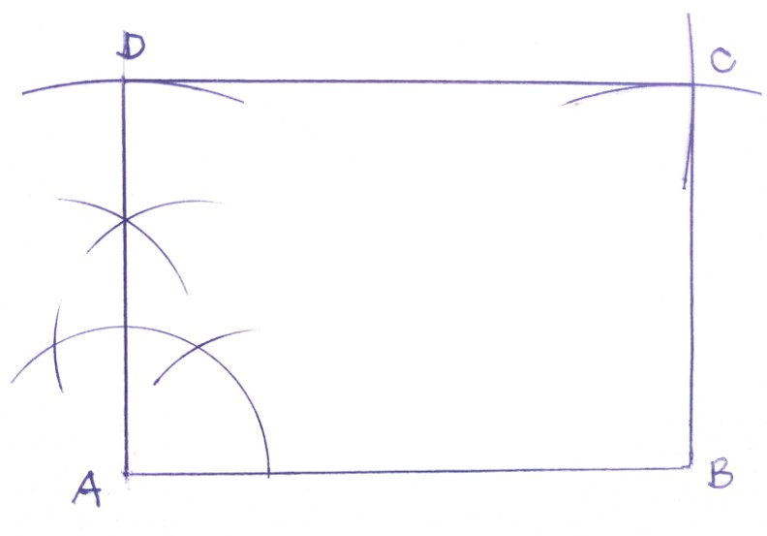

**Figure 5.5 construction of a rectangle**

..

**Observation Checklist**

|  |  |  |  |  |  |  |
| --- | --- | --- | --- | --- | --- | --- |
| **Learning Outcome 5** | | **PC (c) – (e)** | | | |  |
| **No** | **Criteria**  **Based on the specifications given to the Learner by the Assessor** | | **Competence**  **Achieved (A) or**  **Not Achieved (N)** | | |  |
| **A** | **NA** | **Remarks** |  |
|  | Ability to draw plain and diagonal scales | |  |  |  |  |
|  | Able to interpret the plain and diagonal scales  correctly | |  |  |  |  |
|  | Ability to construct geometrical figures using plain and diagonal scales readings | |  |  |  |  |



**Self-Assessment 5**

This learning outcome (LO) has a practical assignment to help you master the skill in explaining scale, reasons for using scale, differences between plain and diagonal scale, draw scale using metric unit and draw basic geometric figures using plain and diagonal scale,

I recommend you spend time and do the practical assignment to help you determine how well you have understood this learning outcome. Now assess yourself with the practical questions below.

You will be provided with equipment and materials to:

**1** Which of the following is a common scale used for architectural drawings?

A. 1:10

B. 1:1000

C. 1:5000

D. 1:20

**2** Why is it important to choose an appropriate scale in technical drawing?

A. To confuse viewers and challenge their perception

B. To make the drawing more abstract and artistic

C. To ensure accurate representation and understanding of the object's size and proportions

D. To save time and effort in the drawing process

3 State two difference between plain and diagonal scale

|  |  |
| --- | --- |
| Plain scale | Diagonal scale |
|  |  |
|  |  |

4 list three reasoning for scale

i)………………………………………………………………………………………………

ii)………………………………………………………………………………………………

ii)………………………………………………………………………………………………

5 Construct a diagonal sale of 30mm =1km to read up to 6km in divisions of 10m

Indicate the following reading (i) 5.81km (ii) 2.53 (iii) 4.67

6 Construct a plain scale of 30mm represents 1m to read up 5m in intervals of 100mm

Indicate the following reading (i) 2.5m ii) 4.5m iii) 1.9m

7 a). Construct a diagonal scale, ten-time full size to show mm and tenth of a mm and to read to a maximum of 20mm

b). Using the scale construct triangle ABC, with AB 17.4mm BC 13.8mm and AC 11mm



We believe you have now acquired skills in explaining

scales, reasons for using scales, differentiate between plain and diagonal scales, draw scales in metric unit, draw basic geometrical figures using diagonal and plain scales as per PC’s (a) – (e).

# References

1. Acquaye, E. A. (2010) Technical Drawing. Yetoda Publishing.
2. Green, J. N. (1988) Technical Drawing. Published By Unwin Hyman Limited
3. M.K Morling (1973) geometric and Engineering Drawing. Edward Amold (Publisher) ltd 41vbedford Square. WC1B London

4 G. Tomlinson (1984) Industrial Workshop Practice. Pitman Publishing ltd128long acre, London WC2E9AN

5 H. A. Freebury Geometrical and Technical Drawing for Secondary School Metric Edition.

6 RS Rhodes &L B Cook (1978). Basic Engineering Drawing Pitman Publishing Ltd.